INTERNSHIP REPORT

**“ACCOUNTING AND AUDIT ASSURANCE”**

**CA G DILIP KUMAR REDDY, A.C.A**

**SUBMITTED IN PARTIAL FULLFILLMENT OF THE REQUIREMENTS OF BACHELOR OF COMMERCE DEGREE OF BANGALORE UNIVERSITY**

**BY**

**DIXITH RAGHAVAN K**

**REG NO-UO3JP21C0134**

**UNDER THE GUIDANCE OF**

**ASSISTANT PROFESSOR MOHAN KUMAR, S.C.C.**



**SHESHADRIPURAM COMMECE COLLEGE MAGADI ROAD, BENGALURU**

## ACKNOWLEDGEMENT

I would like to express my sincere appreciation to Seshadripuram Commerce College for providing me with the opportunity to undertake this internship and integrate practical experience to my academic journey.

I extend my heartfelt appreciation to Sayeed Ahmed V M for their guidance, support, and mentorship throughout the internship period. Their expertise and encouragement have been instrumental in shaping my understanding and skills in Accounting and Audit & Assurance.

I am also thankful to the entire team at CA G DILIP KUMAR REDDY,A.C.A

for their cooperation and assistance during my internship. Their willingness to share knowledge and insight shasenhan Acedmy learning experience and contributed significantly to the completion of this report.

Furthermore, I would like to acknowledge the support received from my academic institution, Seshadripuram Commerce College for facilitating this internship opportunity and for their continuous encouragement in pursuing practical learning experiences.

I would also like to extend my heartfelt thanks to our esteemed faculty coordinator, Mr. Mohan Kumar, and our principal, Smt. Sumathi C, for affording me the chance to embark on this

internship. Their decision to include me in this program has allowed me to gain in valuable knowledge of **Accounting and audit Assurance**

To my parents, I owe a debt of gratitude that words cannot fully express. Your unconditional love, support, and sacrifices have been the foundation of my success. Thank you for always believing in me and for providing me with the opportunities to pursue my passions and dreams.

Your unwavering support and encouragement have been instrumental in helping me navigate through the challenges and triumphs of this internship experience. I am truly blessed to have you in my life.

I would like to express my heartfelt gratitude to my friends for their unwavering support and encouragement throughout my internship journey. Your words of encouragement and belief in me have been a constant source of motivation, and I am grateful for your friendship.

Although this report has been prepared without most care and deep-rooted interest, I acknowledge that it may still have some imperfections. However, I am proud of the effort I have put into it, and I hope it meets the expectation for my mentors and readers.

In concluding my acknowledgment, I extend my deepest appreciation to everyone who has contributed to my internship journey. Your unwavering support, guidance, and encouragement have played a pivotal role in shaping my professional development and enriching my learning experience.

**College Letter Head**



## INDEX

|  |  |  |
| --- | --- | --- |
| **Sl.No** | **TOPICS** | **PAGENO** |
| 1 | EXECUTIVESUMMARY | 8 |
| 2 | Chapter-1 Introduction& organizational profile | 10 |
| 3 | Chapter-2 Design of the study | 40 |
| 4 | Chapter-3 discussion /work description | 46 |
| 5 | Chapter-4 Learning outcomes | 75 |
|  | Bibliography |  |
| A | Annexures | 79 |
| B | Letter of application employer for  Internship | 4 |
| C | Letter of acceptance by employer |  |
| D | Questionnaire/Working sheet(if any) |  |

**EXECUTIVE SUMMARY**

I Dixith Raghavan ,CURRENTLY PURSUING MY GRADUATION IN

B.COM [BACHELOROF COMMERCE]

B.Com (Bachelor of Commerce) is a three-year undergraduate degree that focuses on commerce, economics, businesslaw, accountancy, taxation, and financing.

In Bangalore University, B.COM programme we have subject named internship in which we have to work hard so that training under G Dilip Reddy & Co for a period of 4- 6 weeks.

As a part of my academic career, I completed my internship at G Dilip Reddy & Co for the period of 30 days[90hours].

In this period of my internship have learnt about In this period, I have learnt to Statutory Audit of the areas of Treasury and Debt and Investments. I take this opportunity to thank CA G Dilip Reddy sir for allowing me to leverage the experience I had from my articleship practice in this field of Statutory Audit as part of my CA study and entrusting such critical areas of audit upon me.

## CHAPTER-01: INRODUCTION AND ORGANISATIONAL PROFILE.

**INTRODUCTION:**

An internship is a period of work experience offered by an organization for a limited period. Internship is used practice for a wide range of placements in businesses, non-profit organizations, and government agencies. They are typically undertaken by students and graduates looking to gain relevant skills and experience in a particular field.

An internship serves as a bridge between academic learning and real-world experience. It offers students or recent graduates the chance to apply theoretical knowledge in a practical setting, gaining valuable insight into their chosen field. Internships can vary in duration, structure, and requirements, but they generally provide hands-on training, mentorship, and networking opportunities. Whether in a corporate office, research lab, Non-Profit Organization, or government agency, internships offer a crucial stepping stone for building a successful career by allowing individuals to explore different roles, develop professional skills, and make meaningful connection in their industry.

## TYPES OF INTERNSHIPS:-

Internships can vary in duration, structure, and focus where some common types of internships are:-

* Paid internships.
* Unpaid internships.
* Virtual internships.
* Summer internships.
* Co-opinternships.
* Research internships.
* Corporateinternships.
* Nonprofitinternships.
* Government internships.
* International internships.

Each type of internship offers unique experiences and opportunities for professional development.

## HERE ARE SOME BENEFITS AND CHALLENGES OF INTERNSHIPS

|  |  |  |
| --- | --- | --- |
| **SLNO** | **BENEFITS** | **CHALLENGES** |
| 1 | HANDS-ONEXPERIENCE | UNPAIDPOSITIONS |
| 2 | NETWORKOPPORTUNITIES | LIMITED RESPONSIBILITY |
| 3 | SKILLDEVELOPMENT | COMPETITIVE |
| 4 | RESUMEBUILDING | TIMECOMMITMENT |
| 5 | EXPLORATION | UNCERTAINOUTCOMES |
| 6 | POTENTIALJOBOFFERS | MISMATCHED EXPECTATIONS |
| 7 | ACADEMIC OFFERS | LACKOF BENEFITS |

**TITLE OF STUDY;**

***GST BILLING & TALLY OF PURCHASE AND SALES, A STUDY ON BANK STATEMENTS.***

Table of Contents Introduction Objective Methodology GST Billing Overview of GST.

GST Billing Process Software and Tools used Tally of Purchase and Sales Introduction to Tally Recording Purchases Recording Sales Reconciling Accounts Study on Bank Statements.

Importance of Bank Statements Analyzing Bank Statements Reconciliation with Tally Findings and Analysis Conclusion Recommendations Appendices Sample Invoices Screenshots of Tally Entries Sample Bank Statements

##### Introduction

The purpose of this report is to document the learning and experiences gained during the internship focused on GST billing, tallying purchases and sales, and studying bank statements. The internship was completed at [Company Name], where I was able to apply theoretical knowledge in a practical environment.

##### Objective

The main objectives of the internship were: To understand the process of GST billing. To learn the usage of Tally for recording and reconciling purchases and sales.To analyze and reconcile bank statements with accounting records.

##### Methodology

The study was conducted through: On-the-job training and observation. Practical handling of GST invoices. Regular use of Tally for accounting.Analysis of bank statements and reconciliation with recorded transactions.

##### GST Billing

Overview of GST Goods and Services Tax (GST) is a comprehensive tax levy on manufacture, sale, and consumption of goods and services at a national level. It has replaced many indirect taxes in India.GST Billing Process Invoice Creation: Each sale and purchase transaction is documented via an invoice that includes GST details. Compliance: Ensuring all transactions comply with GST regulations, including correct GST rates and HSN/SAC codes. Software Tools: Utilization of software tools such as [Software Name] for generating GST-compliant invoices.

Software and Tools Used [Software Name] for billing.Tally for accounting.

##### Tally of Purchase and Sales

Introduction to Tally: Tally is an accounting software used for recording financial transactions, managing inventory, and generating reports. Recording Purchases Voucher Entry: Using the Purchase Voucher entry in Tally. GST Entries: Ensuring GST amounts are accurately recorded.

Recording Sales Voucher: Recording sales through Sales Voucher entry. GST Consideration: Including GST in the sales entries. Reconciling Accounts Periodic reconciliation of

Accounts to ensure that all entries match the bank statements and GST filings.

##### Study on Bank Statements

Importance of Bank Statements Bank statements provide a record of all transactions within a bank account, crucial for accurate accounting and reconciliation. Analyzing Bank Statements Transaction Review: Reviewing each transaction to match it with accounting records.Discrepancy Identification: Identifying and investigating discrepancies between bank statements and recorded transactions. Reconciliation with Tally Bank Reconciliation Statement (BRS): Preparing BRS to reconcile bank statements with Tally records. Adjustments: Making necessary adjustments in Tally for unmatched entries.

##### Findings and Analysis

During the internship, the following key findings were observed: Efficient GST billing can streamline tax compliance. Accurate entry of purchases and sales in Tally is crucial for maintaining financial accuracy. Regular reconciliation of bank statements helps in early identification of errors and discrepancies.

##### Conclusion

The internship provided valuable insights into GST billing, accounting in Tally, and the importance of bank statement

reconciliation. The hands-on experience enhanced my understanding of practical accounting processes.

##### Recommendations

Implementing regular training sessions on GST updates for staff. Periodic audits to ensure accuracy in Tally entries. Utilizing advanced reconciliation tools to streamline the bank reconciliation process.

## ORGANISATIONALPROFILE;

A recognized accounting firm providing comprehensive financial and professional services.

S S Auditors and tax consultant’s team of experts offer real world solutions to complex business challenges with expert experience and reliability



S.S Auditors and tax consultants is A tax consultant research tax issues, recommends strategies to minimize and address tax liability, prepares, and files tax returns, and meets with the IRS to represent clients during audits.

Established in 2013 in Bangalore, Karnataka,

S S Auditors and Tax Consultants, one of the most trusted Chartered Accountants, is a full-service accounting company which takes great pride in its impeccable standards of excellence. Over the past13 years, Sayeed Ahmed V M has been working to develop this Business effectively, this organization was managed solely by Sayeed Ahmed in its initial days. He was the only individual who took complete care of the organizational functions and introduced different marketing campaigns to promote the business.

Down the line, Mrs. Sayeed has also been working hard to help the organization in achieving its goals & objectives. The brain child of Sayeed Ahmed V M, Auditor & Business Director S S Auditors, and Tax Consultants are one of the most trusted Chartered Accountants in India today.

It is a name of repute and a full-service accounting company that takes great pride in its impeccable standards of excellence.

## OUR MISSON

The company functions with a mission to provide outstanding financial and technical services while upholding integrity and professionalism at the highest levels and guide the customers in fulfilling their current and potential needs and help them cultivate long-term success. Also, the company focuses on creating a lively, open atmosphere that promotes innovative thinking, creative ideas and challenges workers to achieve their optimal success levels and creates a harmonious equilibrium between family life and work. S S Auditors and Tax Consultants’ team of experts offer real-world solutions to complex business challenges with expert experience and reliability. The company provides services like Accounting, Filing of VAT, Service Tax, Income Tax, e-TDS, Professional Tax, Provident Fund (PF), Employees State Insurance (ESI) and Labor License, Food License, Trade License, DSC, Registration of Firms, Incorporation of Companies, Internal Auditing, Patents and many more. Auditors and tax advisors offer realistic, innovative, and simple solutions to complicated business challenges and are proud of the long-standing partnership that the founder has formed with its customers, many of whom are industry leaders in their respective fields. The motto of the organization is to be universally known with an immaculate level of excellence as a trustworthy company. The market driven framework allows S S Auditors and Tax Advisors provide their customers with an educated view point on the problems of the industry.

Our approach provides high quality services at the right time for our customers. We provide fast and personalized services with an individual partner or principal managing each customer's affairs to meet each customer's needs, also recognize that potential opportunities are missed without absolute direction and appropriate clinical assistance, and all seem stressful and even produce compromised results.

## STAYING WITH THE RULES

Various rules and regulatory compliances that the company adheres to while offering their services are the Income-tax Act of 1961, the GST 2017 Act, Companies Act of 2013, and the National Insurance Act of 1946.S S Auditors and Tax Consultants have a very strong client base with the clients like Fashion Degree Private Limited, Riders Technologies Pvt. Ltd, IN Engineering Works and many more.

## OURSERVICES



* GST TAX
* Income Tax
* ESIPF
* Service Tax
* Companies ACT
* Sales Tax
* Registration

# OURBUSINESS

* + **BUSINESS REGISTRATION**
* Limited Liability Partnership
* Partnership Firm
* PVTLTDCompany
* MSME Registration
* Nidhi Company
* 12A & 80G Registration
* Company Registration
* Public Limited Company
* Society Registration
* ProducerCompany
* One Person Company
* Sole Proprietorship

## SPECIAL ENTITIES

* Trust registration
* RWA registration
* NGO registration

## GOVERNMENT AND TAX REGISTRATION

* Professional Tax Registration
* PSARA Registration
* Trade License
* Excise Registration
* TAN Registration
* Import Export Code
* Digital Signature Certificate
* FSSAI License (Food License)
* Ayush License
* STPI Registration

## TAX FILING

* LLP Annual Filing
* Business Tax Returns Filing
* TDS Return Filing
* Income Tax Returns Filing

## ANNUAL COMPLIANCES

* ROC Compliances
* LLP Compliances
* DIR-3 Director KYC
* Partnership
* Firm Compliances
* PVT LTD
* Company Compliances
* Proprietorship Compliances
* Form DPT-3 Filing

## VALUATION

* Property Valuation
* Jewellery Valuation
* Income Tax Valuation
* Capital Gain Valuation
  + **CONVERSION & CLOSURE**
* Close PVTLTD Company
* Partnership OfLLP
* Winding Up Company
* PVTLTD to One Person Company
* Winding Up OfLLP
* PVT LTD TO Public LTD Company
* Sole Proprietorship to PVTLTD

## CHANGES IN BUSINESS

* Company Name Change
* Add Directorin Company
* Remove Directorin Company
* Company ShareTransfer
* Increase Authorized Share
* Capital
* MOA Amendment
* Add Partner In LLP

➢

* Payroll Services

## PAYROLL COMPLIANCES

* Provident Fund Registration
* Employee State Insurance (ESI)
* Employee Stock Option Plan (ESOP)

## IPR (INTELLECTUAL PROPERTY REGISTRATION)

* + **TRADE MARK**
* ESI return filing

## QUALITY CERTIFICATION

* ISO Registration
* ISI Mark Certification
* BEE Certification
* Agmark Registration
* FCC Certification
* GS Mark Certification
* Halal Certification
* Hallmark Registration
* UL Certification

## AUDIT AND ASSURANCE

* Statutory Audit
* Bank Statutory Audit
* Revenue Audit
* Internal Audit
* Concurrent Audit
* Bank Concurrent Audit
* Proprietary Audit
* Stock Audit

## OUTSOURCING, ACCOUNT & TAXATION

* Book keeping & Accounting
* TDS & Withholding Tax
* Expatriate Taxation
* Account Outsourcing

## MANAGEMENT & TAXPLANNING

* Income Tax Matters & Tax Planning
* Design, Implementation & Review of Accounting Manual

## LICENSE&REGISTRATION

* LUT Bond Registration
* FFMC License

#### CONSULTANCY

* TDS Certificate
* Assessment of Income Tax Return
* Preparation of Income Tax
* Accounting Standards
* GST Registration
* GST Return Filing
* GST LUT Filing
* Temporary GST Registration
* GST Registration Cancellation

## LICENSES/ REGISTRATION

* Trademark Registration
* Trademark Objection
* Trademark Renewal
* Trademark Assignment
* Trademark Restoration
* Trademark Hearing
* Trademark Opposition
* Trademark Rectification
* Trademark Classes

## COPYRIGHT

* Copyright Registration
* Copyright Objection

## PATENT

* Patent Registration
* Patent Search
* Provisional Patent

## DESIGN

* Design registration

## GST

* + - [GSTRegistration](https://www.ssauditor.com/items-14/gst-registration)
    - [GSTReturn Filing](https://www.ssauditor.com/items-14/gst-return-filing)
    - [GSTLUTFiling](https://www.ssauditor.com/items-14/gst-lut-filing)
    - [Temporary HYPERLINK"https://www.ssauditor.com/items-14/temporary-](https://www.ssauditor.com/items-14/temporary-gst-registration) [gst-registration"GSTRegistration](https://www.ssauditor.com/items-14/temporary-gst-registration)
    - [GSTRegistration Cancellation](https://www.ssauditor.com/items-14/gst-cancellation)

## OUR CLIENTS











**CHAPTER -02:DESIGN OF THE STUDY**

Goods and Services Tax (GST) stands as a corner stone of modern taxation systems, aiming to streamline in direct taxation while fostering economic growth and simplifying compliance procedures. Enacted in many countries around the world, GST represents a paradigm shift in tax administration, merging multiple taxes into a unified structure.

This internship report chronicles my journey and insights gained during my tenure in the field of GST. Through this internship, I aimed to deepen my understanding of GST's intricacies, its implementation challenges, and its implications on businesses and the economy at large. By delving into practical applications and real-world scenarios, this report encapsulates the transformative experience of engaging directly with GST processes, policies, and practices.

It encapsulates the practical experiences, challenges faced, and lessons learned in grappling with GST intricacies first hand. Through this report, fellow students gain a glimpse into the practical applications of theoretical knowledge, as well as the significance of GST in shaping future career paths and contributing to the broader economic discourse.

For students embarking on their professional journey, understanding Goods and Services Tax (GST) is paramount in navigating the complexities of modern taxation systems. GST not only shapes the economic landscape but also influences business strategies and consumer behaviors. As budding professionals,

33

delving into the realm of GST offers invaluable insights into fiscal policies, regulatory frameworks, and their implications on various industries.

The internship offered a comprehensive exploration into the seamless integration of Goods and Services Tax (GST) processes across multiple platforms, including the GST portal, billing systems, and Tally accounting software. This report provides an overview of the experiences, challenges, and insights gained during the internship period, highlighting the synergies between these platforms in ensuring efficient GST compliance and financial management.

## OBJECTIVES

1. Gain proficiency in navigating the GST portal for tax registration, filing returns, and compliance activities.
2. Understand the intricacies of GST billing processes and their Alignment with GST regulations and tax rates.
3. Explore the integration of GST billing with Tally accounting software for streamlined financial reporting.
4. Identify opportunities for optimizing workflows and enhancing Efficiency in GST compliance across platforms.

**ROLESAND RESPONSIBILITIES**

##### GST Portal of purchase and sales Bill.

* + - Registration: Assisted businesses in registering for GST on the portal, ensuring accurate submission of required

34

documents and information.

* Return Filing: Prepared and filed GST returns on behalf of clients, adhering to the specified due dates and compliance requirements.
* Payment Processing: Facilitated online payment of GST liabilities through the portal, ensuring timely settlement of taxes.

## BILLING SYSTEMS

* Invoice Generation: Generated GST-compliant invoices and bills using billing software, accurately calculating tax components based on product classifications and rates.
* Compliance Monitoring: Monitored billing processes to ensure adherence to GST regulations and guidelines, identifying and rectifying discrepancies as needed.
* Integration with GST Portal: Established seamless integration between billing systems and the GST portal to facilitate automatic data transfer for return filing and compliance activities.

## TALLY INTEGRATION

* Configuration: Configured Tally accounting software settings to align with GST requirements, including tax rates, input tax credits, and reporting structures.
* Data Entry and Reconciliation: Entered billing data into Tally software, reconciling it with GST portal records to ensure Consistency and accuracy in financial reporting.

35

* Reporting and Analysis: Generated GST reports within Tally for internal review and analysis, providing insights into tax liabilities, input credits, and compliance status.

**TASKS**

* Explored various modules of the GST portal, including registration, return filing, and payment processes.
* Assisted in generating GST-compliant invoices and bills using billing software, ensuring accurate calculation of taxes.
* Configured Tally software settings to align with GST requirements and integrated billing data for seamless financial reporting.
* Collaborated with cross-functional teams to troubleshoot issues and optimize GST workflows across platforms.

## SKILLS DEVELOPED

* Proficiency in navigating and using the GST portal for tax compliance and reporting.
* Understanding of GST billing processes and their integration with accounting software like Tally.
* Attention to detail in ensuring accuracy and compliance in GST transactions and financial reporting.
* Creating a company intally software
* Tallying the bills of sales and purchase including receipt and payments

36

## CHALLENGES FACED

* + Navigating the complexities of configuring and integrating multiple platforms for seamless GST compliance.
  + Addressing discrepancies and errors in GST transactions across platforms, requiring meticulous attention to detail and thorough reconciliation.
  + Keeping abreast of updates and changes in GST regulations and software functionalities to ensure ongoing compliance and optimization.

## OUTCOMES AND IMPACT OF SALES AND PURCHASE

The outcomes and impacts of sales and purchase activities within a business can be diverse and significant. Here are some key outcomes and impacts:

### Revenue Generations:

Sales activities directly contribute to revenue generation for the business. Increasing sales volumes and prices can lead to higher revenues, positively impacting the financial health and sustainability of the business.

37

### Profitability:

The difference between the sales revenue and the cost of goods sold **(CDGS)** determines the profitability of sales. Effective Purchase practices, such as negotiating favorable terms with suppliers and optimizing inventory levels, can help improve profitability by reducing CDGS and increasing gross margins.

### Market Expansion:

Successful sales efforts can lead to market expansion by attracting new customers and penetrating new markets. Increased market share and brand visibility can enhance the business’s competitive position and long term growth prospects.

38

# CONCLUSION

The internship provided valuable insights into the diverse roles and responsibilities involved in managing GST compliance across the GST portal, billing systems, and Tally software. By immersing myself in practical tasks and collaborating with experienced professionals, I gained a deeper understanding of the interconnected functions of these platforms and their collective impact on ensuring seamless GST compliance and financial reporting. This report serves as a testament to the enriching experience and the contributions made towards advancing the organization's GST compliance objectives through effective coordination and integrationamong multiple platforms.

**\*\*\*\*\*\*\*\*\*\***

39

## CHAPTER -03: DISCUSSION OR WORK DESCRIPTION

**Monthly activity summary**

**Date – 24/04/2024 to 24/5/2024. Work timings- 1:00pm to 5:00pm**

# Introduction of GST

#### GST [GOODS AND SERVICES TAX]

The Goods and Services Tax (GST) is a comprehensive indirect tax levied on the supply of goods and services across India. It replaced multiple cascading taxes levied by the central and state governments, aiming to streamline the taxation system, reduce tax evasion, and create a unified national market. Implemented on July 1, 2017, GST is a destination-based tax, meaning it is levied at the point of consumption rather than at the point of origin.

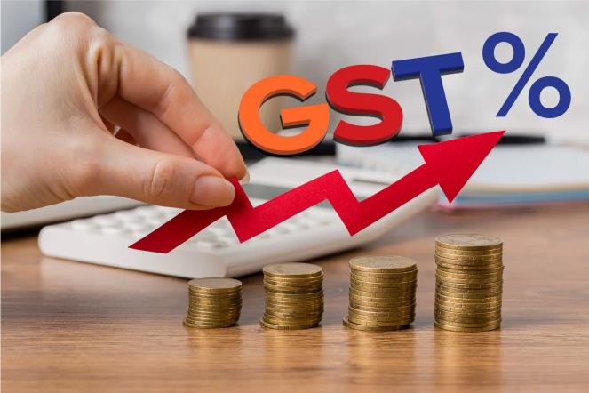

40

Arun Jaitley introduced the GST Bill in the Lok Sabha, in February 2015. GST is implemented in India from 1 July 2017. Goods and Services Tax (GST) is a type of indirect tax that was introduced in the constitution by the 101st constitution amendment act, 2016. Goods and services tax [GST] can be categorized into various types based on the nature of goods or services such as:

1. Central Goods and Services Tax (CGST): Levied by the Central Government on intra-state supplies of goods and services.
2. State Goods and Services Tax (SGST): Imposed by the State Governments on intra-state supplies of goods and services.
3. Integrated Goods and Services Tax (IGST): Applied by the Central Government on inter-state supplies of goods and services and imports.
4. Union Territory Goods and Services Tax (UTGST): similar to SGST but applicable in Union Territories without legislatures.

These are the primary types of GST implemented in India's taxation system.

### Sales bills entries in tally

**Sales bills**

"Sales bills" refer to the documents generated by a seller to formalize the sale of goods or services to a buyer. These bills serve as evidence of the transaction and contain crucial

41

information about the sale. Here's what they typically include: Sales bills are legally binding documents that provide proof of the transaction and help in maintaining accurate financial records for both the seller and the buyer. They facilitate smooth business operations, aid in inventory management, and play a crucial role in accounting, taxation, and audit processes.

### Tally

“Tally” ERP 9 is the primary software product developed by Tally Solutions. It is an integrated business management software that helps businesses streamline their operations, manage finances, and comply with regulatory requirements. Tally.ERP 9 is designed to cater to the needs of small, medium, and large enterprises across various industries. It offers features such as accounting, inventory management, invoicing, banking, taxation, payroll, and more. The software is known for its user- friendly interface, robust functionality, and scalability.



The work I was assigned by MS Akhila ma’am, and it was to enter the sales of various companies into the tally software [Tally.ERP 9].and they taught me how to enter the sales bills in it.

42

And more into it I learned about how to create /shut the company in tally

How to create a company in tally;

**STEP 1-** Open the tally.ERP 9 software.

**STEP 2**- Click on cmp info.

**STEP 3**- Click on create company.

**STEP 4-** Fill in the required details such as company name, company details, mailing address, mailing name, address, statutory compliance, financial year,etc

**STEP 5-** After filing the details, press enter to save thee company information.

**STEP 6-** Tally will prompt you to confirm the details entered. Confirm to create the company.

Once the company is created, you can start entering transactions and managing your accounts within the company.

**NOTE:** Remember to enter accurate information as this will be used for all your transactions and reports within tally.ERP 9.

43

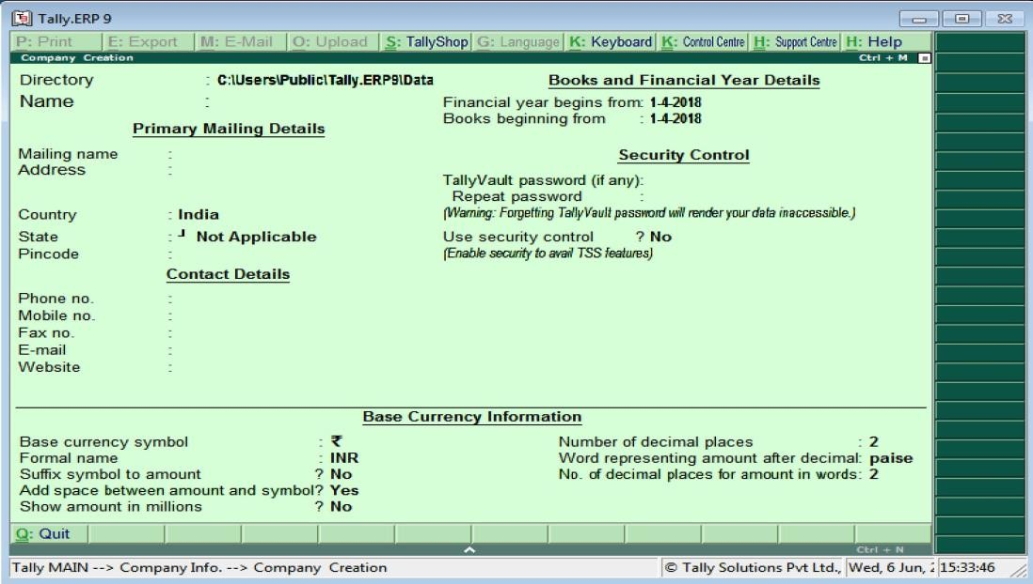

After creating a company. I got the sales bills/receipts and started to enter in the tally.ERP 9 software.

#### ENTERING THE SALES BILLS IN TALLY

After creating a company in the tally software

I got the sales bills/ receipts from one of their employees and I verified the bills first then I started entering the bills in tally.

How do you enter the bills in tally **STEP 1**- Firstly verify the sales bills. **STEP 2**- Click on accounting vouchers. **STEP 3**- Click on sales.

**STEP 4**- Click on AS voucher.

**STEP 5**- Enter the invoice number and date.

44

**STEP 6**- Select the name of the customer from whom you made the sale.

**STEP 7**- Add the ledger account of the company [in case if its new, click alt+c then a ledger creation page will appear and enter the basic details like ledger account name then add the other basic details which is given there and save it]

**STEP 8**- After adding the ledger account enter the amount that is given in bill.

First add total taxable amount

**STEP 9**- Create a new ledger account naming sales and enter the total sales amount.

After adding the amount, look at bills and clarify whether there is a GST rate and add it to the tally.

**STEP 10**- Add the GST rates that is given in the bills,

For example, if the sales are taken place within the state the GST rates is divided into two types, that is CGST [central goods and services tax]

And SGST [ state goods and services tax] The tax rate should be divided to CGST and SGST equally.

Or if the sales are taken place in different states, then IGST [integrated goods and services tax] will be applicable

Example the tax rate Is 18%

45

CGST =9%

SGST =9%

IGST =18%

That’s how we divide the tax rate into different types of GST.

**STEP 11**- After entering the GST rates, check whether the amount is tallied.

**STEP 12**- Verify and save the voucher. What if the amount is not tallied?

If the amount is not tallied, we must double check the entries. If we did any mistakes, we must correct them.

What if there is a round off in the sales bills?

Round off refers to the process of adjusting the final total amount of a transaction to a specified decimal point or nearest whole number. This feature helps in ensuring that the financial statements are presented with appropriate precision and conformity to accounting standards. Tally allows users to configure rounding off settings according to their preferences and accounting requirements.

If there is a round off in the bill, we must create a separate ledger account, that is ‘ROUND-OFF’ and the tally software will automatically round off the remaining amount and then the entries will be tallied.

46

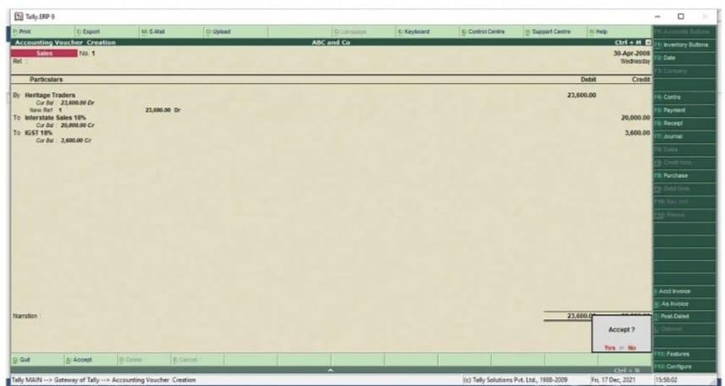

**Purchase bills**

## PURCHASE BILL IN TALLY

"Purchase bills" are documents issued by a seller to a buyer as evidence of the purchase of goods or services. These bills contain essential details about the transaction and serve as a record of the purchase. Here's what purchase bills typically include:Purchase bills are crucial documents for both the buyer and the seller. For the buyer, they provide proof of the purchase transaction and aid in accounting and financial management. For the seller, they serve as evidence of revenue generated and help in maintaining accurate records for taxation and regulatory compliance.

What are the details that are given in purchase bills?

1. Invoice Number: A unique identifier for the purchase bill.
2. Date: The date when the purchase transaction occurred.

47

1. Supplier Information: Details about the seller, including name, address, and contact information.
2. Buyer Information: Details about the purchaser, including name, address, and contact information.
3. Item Description: Detailed descriptions of the purchased items, including product names or codes.
4. Quantities: The number of units of each item purchased.
5. Unit Prices: The price per unit of each item.
6. Total Amount: The total cost for each item line (quantity multiplied by unit price).
7. Sub-Total: The total amount before any taxes or discounts.
8. Taxes: Details of any applicable taxes, such as GST or VAT, including the tax rate and amount.
9. Discounts: Any discounts applied to the total or specific items.
10. Grand Total: The final amount payable, including all taxes and after applying any discounts.
11. Payment Terms: Terms of payment, including due date and any early payment discounts.
12. Purchase Order Reference: Reference to the corresponding purchase order, if applicable.
13. Notes or Additional Terms: Any additional terms, conditions, or notes relevant to the purchase.

These details ensure clarity and completeness of the transaction, facilitating smooth business operations and accurate financial tracking.

48

### Purchase bills entries in tally.

After completing the previous work that was to enter the sales bills in tally the next work, I was assigned to enter the purchase bills in tally.

How to enter purchase bills in tally?

Its same as the entries done in sales tally but with certain differences.

**STEP 1**- Check the purchase bills before entering to tally.

**STEP 2**- Open the tally.ERP 9 software.

**STEP 3**- Select the company if it exists already [ if it doesn’t exist create a new company]

**STEP 4**- After selecting or creating company click on accounting vouchers.

**STEP 5**- Select the voucher types as PURCHASE by pressing F9.

**STEP 6**- After selecting the purchase voucher is opened.

**STEP 7**- Add invoice number and supplier invoice number and date.

**STEP 8**- Add company’s name.

**STEP 9**- Enter total taxable amount.

**STEP 10**- Create a new ledger “PURCHASE”

49

**STEP 11**- Add the total amount in the purchase ledger. After adding both total taxable amount and total amount

And check the purchase bill, and check the GST rates and enter it in tally

Tally will automatically calculate the total amount and taxes based on information provided.

**STEP 12**- If GST is applicable, add the relevant GST tax ledgers such as CGST, SGST, IGST to the purchase voucher.

**STEP 13**- After entering all the purchase details, verify them to ensure accuracy.

**STEP 14**- Press ctrl+A or click on the “ACCEPT” button to save the purchase voucher.

By the following steps, you can efficiently enter purchase bills in tally.ERP 9, ensuring accurate recording of transactions for accounting and tax compliance purposes.

50

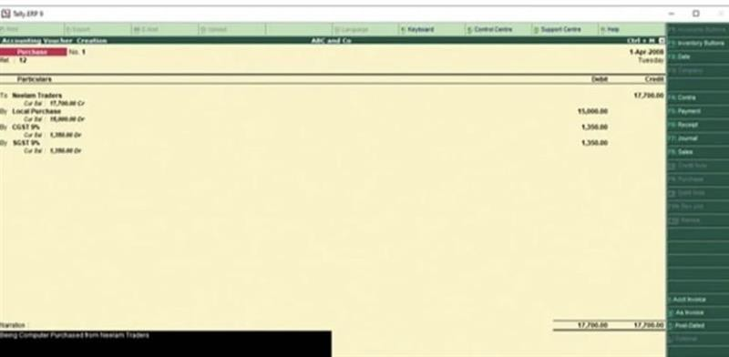

#### ROUND OFF

"Purchase bills” round off refers to the process of adjusting the total amount of a purchase bill to a rounded figure for practical or accounting reasons.In some cases, businesses may choose to round off purchase bills to the nearest whole number or a specified decimal place for simplicity in payment or accounting. Rounding off purchase bills can streamline accounting processes and make transactions easier to manage. However, it's important to ensure that rounding practices are consistent and comply with relevant regulations or company policies.

#### STEPS

Round off in the context of GST (Goods and Services Tax) typically refers to the process of rounding off the tax amount to

51

the nearest whole number or to the nearest multiple of five. Here are the general steps involved in rounding off GST:

* **Calculate GST**: Calculate the GST amount applicable to the transaction. This is usually done by multiplying the taxable value of goods or services by the GST rate (e.g., 5%, 12%, 18%, etc)
* **Determine Rounding Rule**: Decide on the rounding rule to be applied. In many jurisdictions, GST amounts are rounded off to the nearest whole number (nearest integer) or to the nearest multiple of five cents.
* **Check the Decimal**: Check the decimal part of the calculated GST amount. If it is less than half of the smallest unit to which it will be rounded (e.g., less than 0.5 if rounding to the nearest whole number), round down. If it is equal to or greater than half, round up.
* **Apply Rounding**: Apply the rounding rule chosen in step 2 to round the calculated GST amount accordingly.
* **Adjust the Final Amount**: Add or subtract the rounded GST amount to/from the total amount, depending on whether the tax is being added to or deducted from the base amount.
* **Recordkeeping**: Maintain records of the original calculated GST amount, the rounding adjustment made, and the final rounded GST amount for compliance and auditing purposes.

52

* **Documentation**: Ensure that all documentation related to the transaction, such as invoices or receipts, reflects the rounded GST amount.
* **Compliance**: Ensure compliance with relevant tax laws and regulations regarding rounding off GST amounts. Different jurisdictions may have specific rules regarding rounding off GST.

These steps ensure that GST amounts are rounded off accurately and in compliance with applicable regulations, helping to facilitate smooth transactions and accurate financial reporting.

## SLAB RATES OF GST AND INCOME TAX

##### Slab Rate.

The term "slab rate" typically refers to a progressive tax system where different portions of income are taxed at different rates. In such a system, income is divided into "slabs" or brackets, with each slab taxed at a different rate. As income increases, the tax rate generally increases as well.

#### SLAB RATE OF GST

In the context of GST (Goods and Services Tax) in India, the term "slab rate" specifically refers to the different tax rates applied to goods and services under the GST regime. India's GST system has multiple tax slabs, including 0%, 5%, 12%, 18%, and 28%, with certain goods and services exempted or taxed at a nil

53

rate. These slabs determine the amount of GST payable on transactions.

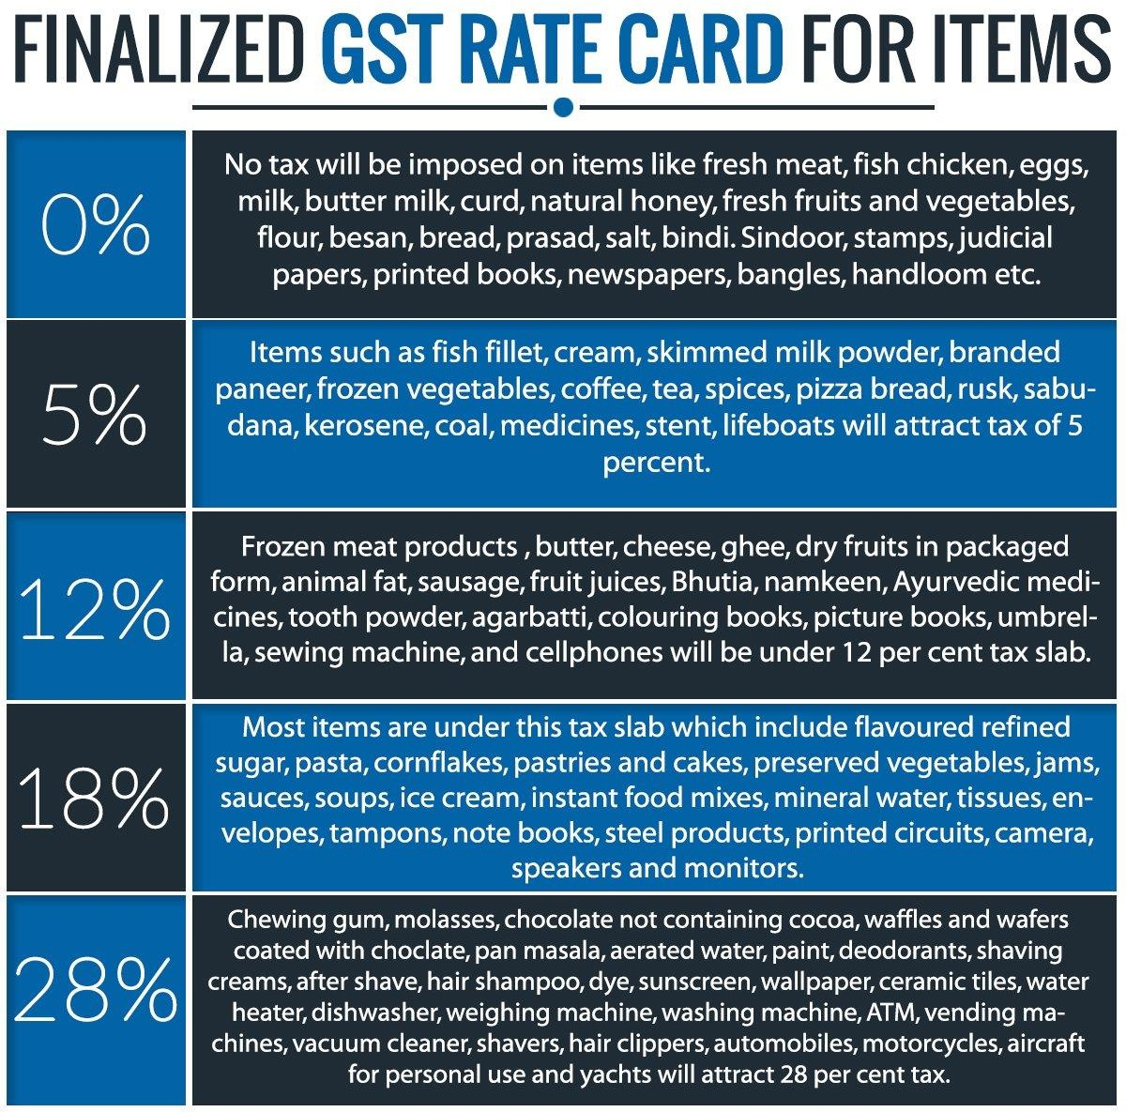

#### SLAB RATES OF INCOME TAX

In income tax, "slab rate" refers to the progressive tax system where different portions of an individual's income are taxed at different rates. Income is divided into slabs or brackets, with each slab taxed at a different rate. As income increases, the

54

tax rate typically increases as well. For example, in many countries, there are different tax rates for different income ranges, such as 0-10%, 10-20%, and so on, with higher rates applied to higher income brackets.

## OLD TAX REGIME

|  |  |
| --- | --- |
| **INCOME SLAB (₹)** | **INCOME TAX RATE** |
| Up to 0 – ₹250,000 | NIL (basic exemption limit) |
| ₹250,000₹ to ₹500,000 | 5% |
| ₹500,000₹ to ₹10,00,000 | 20% |
| MORE THAN₹10,00,000 | 30% |

For example, if someone earns ₹7,00,000 in a financial year: They pay no tax on the first ₹2,50,000.

They pay 5% tax on the next ₹2,50,000 (₹5,00,000 -

₹2,50,000).=12,500

They pay 20% tax on the next ₹2,50,000 (₹7,00,000 -

₹5,00,000).=40,000

They don’t fall into the fourth slab as their income is below

₹10,00,000.

Total tax calculation;

Total tax liability = ₹0+₹12,500+40,000= ₹52,500.

55

Under the old tax regime, individuals could also avail deductions and exemptions under various sections of the Income Tax Act to further reduce their taxable income.

## NEW TAX REGIME

|  |  |
| --- | --- |
| **INCOME SLAB (₹)** | **INCOME TAX RATE** |
| Up to ₹300,000 | NIL |
| ₹300,000 to ₹600,000 | 5% |
| ₹600,000 to ₹900,000 | 10% |
| ₹900,000 to ₹12,00,000 | 15% |
| ₹12,00,000 to ₹15,00,000 | 20% |
| More than ₹15,00,000 | 30% |

For example, if someone earns ₹12,00,000 in a financial year Tax income up to ₹300,000: 0

5%tax income from ₹300,000 to₹600,000:15,000. 10%Tax income from ₹600,000 to ₹900,000:30,000 15% tax income from ₹900,000 to ₹12,00,000:45,000 Total tax calculation ;

Total tax liability = ₹0+₹15,000+₹30,000+₹45,000=₹90,000.

## GST RETURNS

56

GST returns are periodic filings that businesses registered under the Goods and Services Tax (GST) system need to submit to the tax authorities. These returns contain details of sales, purchases, tax collected on sales (output tax), and tax paid on purchases (input tax). The purpose is to reconcile the taxes collected and paid by the business and ensure compliance with GST regulations.

GST returns are like reports businesses give to the government, showing how much, they sold, bought, and the taxes they collected and paid. It helps the government keep track of taxes and ensure businesses follow the rules.

##### Types of GST returns:-

GSTR-1: Details of outward supplies of taxable goods and/or services.

GSTR-3B: Summary of outward and inward supplies, along with the tax liability.

GSTR-4: Quarterly return for composition scheme taxpayers.

GSTR-9: Annual return consolidating the details furnished in the monthly/quarterly returns.

GSTR-9C: Reconciliation statement, along with the certification by a Chartered Accountant or Cost Accountant, for taxpayers above a certain turnover threshold.

GSTR-5: Monthly return for non-resident taxable persons.

57

GSTR-6: Monthly return for Input Service Distributors (ISDs). GSTR-7: Monthly return for tax deducted at source (TDS).

GSTR-8: Monthly return for tax collected at source (TCS).

GSTR-10: Final return for taxpayers whose GST registration has been canceled or surrendered.

These are some of the main types of GST returns in India, each serving a specific purpose and filed by the different types of the taxpayers.

## GSTR1 FILING ON GST PORTAL.

GST portal.

#### GSTR 1 FILING ON GST PORTAL

Every registered dealer is required to file the GSTR-1 return for each month/quarter as applicable. The return contains details of all outward supplies made during that particular tax period.

The due date for GSTR-1 is usually 11th of the succeeding month. For quarterly filers, the due date is the 13th of the month following the quarter.

The GSTR-1 return can be filed on the GST Portal/ GSTN. But there are some challenges that you may face while importing data:

If the number of sales invoices is more than 500, then the GST Offline Utility has to be downloaded and the return file needs to be generated from this offline utility.

58

There is no option to perform bulk action on invoices. The HSN-wise summary has to be manually filled in. Try Clear GST Software to file returns quickly:

Bulk import and updating of sales invoices

Upload of sales details at a click of a button. No need to login to the GST Portal.

Auto filling of HSN-wise summary based on sales details imported by you.

**Log in and navigate to the GSTR-1 return**

* + **Login to the GST Portal**
  + **Go to Services. In the drop-down click on Returns > Returns Dashboard**

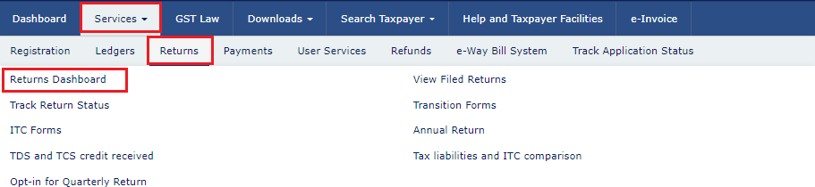

**Select quarterly or monthly GSTR-1 filing**

On the ‘File Returns’ page, select the Financial Year, Quarter and Period (Month) for which you want to file the return from the drop-down list. Click on the ‘SEARCH’ button.

Thereafter, on the GSTR-1 return page, the return filer has two option – Prepare the return online or offline. Let us take a

59

look at the process of preparing the return online. Click on ‘Prepare online’.

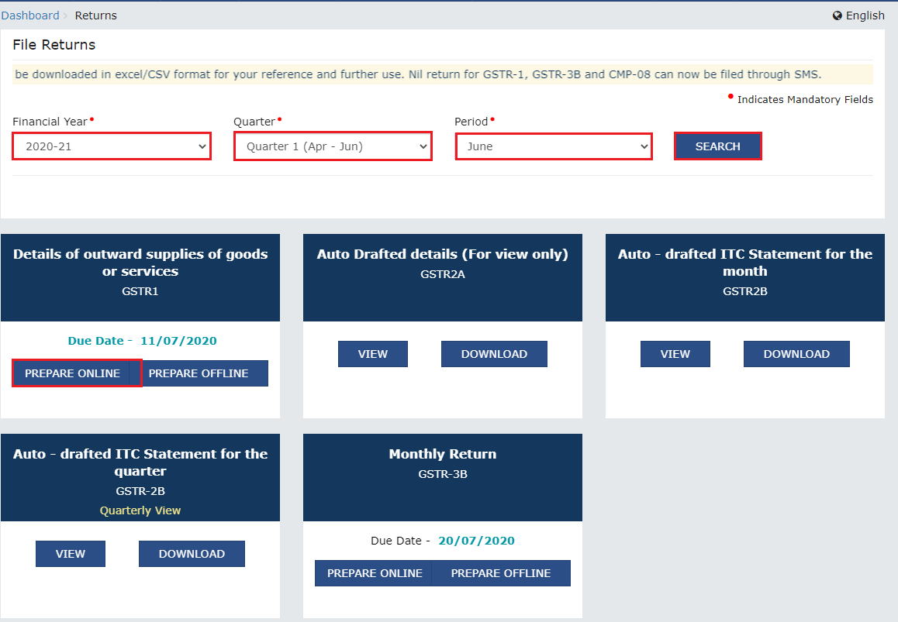

##### Download and edit e-invoice data (if applicable)

This section is applicable to e-invoicing applicable entities only. The GST Portal gets e-invoice details from IRP and updates it in your GSTR-1 in 2 days. The following are the tables where the e- invoice details are auto-populated in GSTR-1.

* 4A, 4B, 4C, 6B, 6C – B2B Invoices
* 6A – Export Invoices
* 9B – Credit/Debit notes (Registered) – CDNR
* 9B – Credit/Debit notes (Unregistered) - CDNUR

Click on the ‘DOWNLOAD DETAILS FROM E-INVOICES (EXCEL)’

button to access the e-invoice details.

60

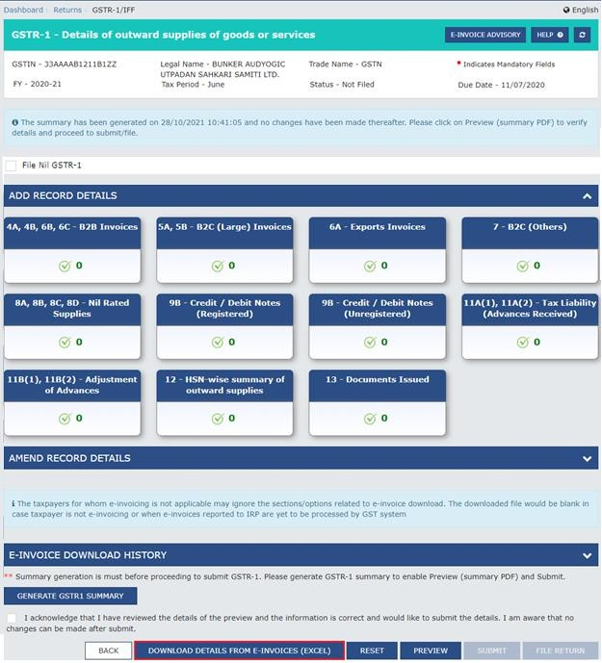

##### Enter details for the current tax period in the various tiles GSTR-1 – Invoice Details

* 4A, 4B, 4C, 6B, 6C – B2B Invoices
* 5A, 5B – B2C (Large) Invoices
* 9B – Credit / Debit Notes (Registered)
* 9B – Credit / Debit Notes (Unregistered)
* 6A – Exports Invoices
* 9A- Amended B2B invoice

61

* 9A- Amended B2C large invoice
* 9A- Amended Export invoices
* 9C- Amended Credit/Debit Notes (Registered)
* 9C- Amended Credit/Debit Note (Unregistered)

##### GSTR-1 – Other Details

* 7- B2C Others
* 8A, 8B, 8C, 8D – Nil Rated Supplies
* 11A(1), 11A(2) – Tax Liability (Advances Received)
* 11B(1), 11B(2) – Adjustment of Advances
* 12 – HSN-wise-summary of outward supplies
* 13 – Documents Issued
* 11A – Amended tax liability (Advance received)
* 11B Amended of Adjustment of Advances
* 10- Amended B2C (Others)

## B2B

1. 4A, 4B, 4C, 6B, 6C – B2B Invoices

All B2B Invoice details are required to be entered inside this

tile.

Step 1 – Click on the 4A, 4B, 4C, 6B, 6C – B2B Invoices tile. Step 2 – Click on Add Invoice

62

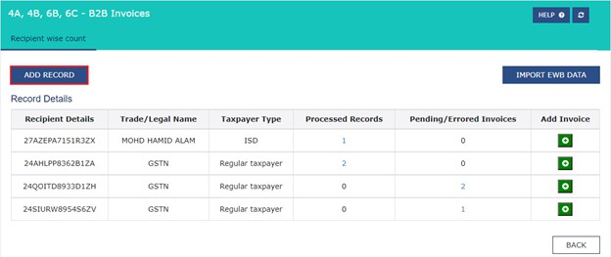Step 3 – The following details should be entered on this page – Select the check box for Deemed Exports, SEZ Supplies with

Payment or SEZ Supplies Without Payment, if applicable.

Enter the receivers GSTIN/ UIN . Once this is done the Receivers Name, POS and Supply Type will be auto populated.

Enter the Invoice No., Invoice Date and Invoice Value

In case the supply attracts reverse charge or supply is through e- commerce operator select the check box.

Enter the Taxable Value of supplies made in the taxable value field. Based on inter-state or intra-state transactions CGST and SGST or IGST will appear in the amount of tax field. The Amount of tax is auto calculated based on the taxable value entered.

Click on Save once all the details are entered.

63

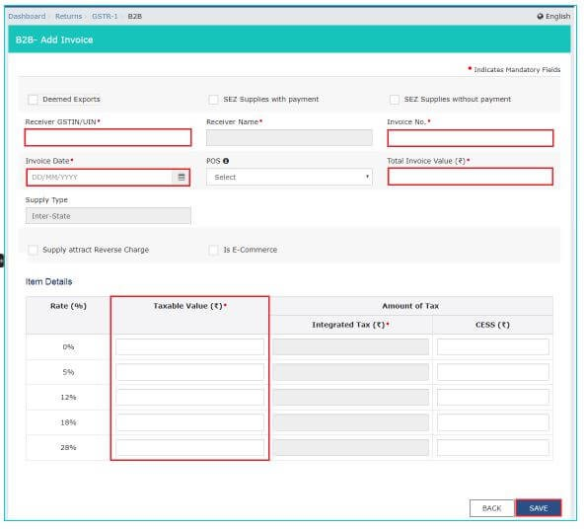

Step 4 – You will be redirected to a page where you can see the summary of all the invoices entered. You can edit/delete invoices here (under Actions).

64

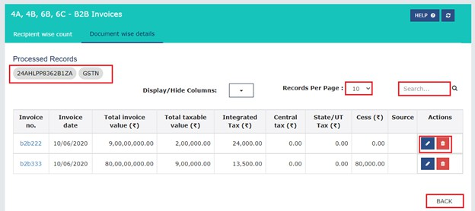

Step 5 – Click the BACK button to go back to the Invoices – Receiver-Wise-Summary page. You can add invoice of a particular receiver by clicking on a receiver details and clicking on add invoice button at the bottom of the page.

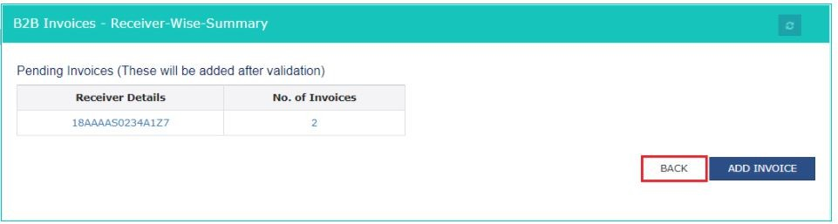

Step 6 – Click on Back button to go back to GSTR-1 page. You will see that the B2B Invoices tile in GSTR-1 reflects the number of invoices added.

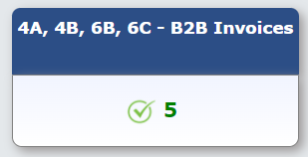

65

### B2C Others

##### 7- B2C Others

All supplies that are B2C and the amount is less than Rs 2.5 lakh, the details of those invoices have to be entered here.

Step 1 – Click on the 7- B2C Others tile.

Step 2 – Select E-commerce tab to add details for a transaction through E-commerce or else select Other than E-commerce tab in case transaction is through non E-commerce. Click on Add Details button on the bottom right.

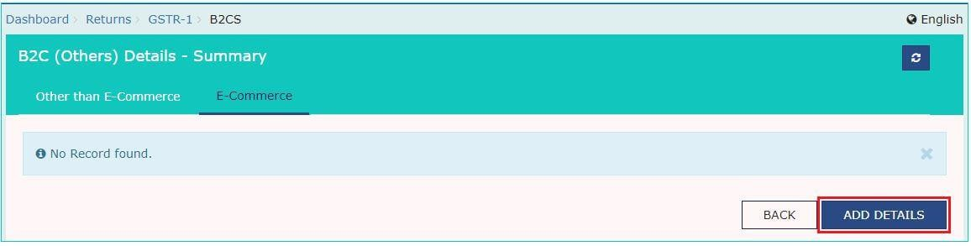

Step 3 – The following details have to be entered here –

Select Place of Supply (State Code) where supply was delivered. The Supply Type field gets auto populated

Enter the Value of Taxable supplies made Select Rate of GST applicable

Enter GSTIN of e-commerce operator(if any) Click on Save

66

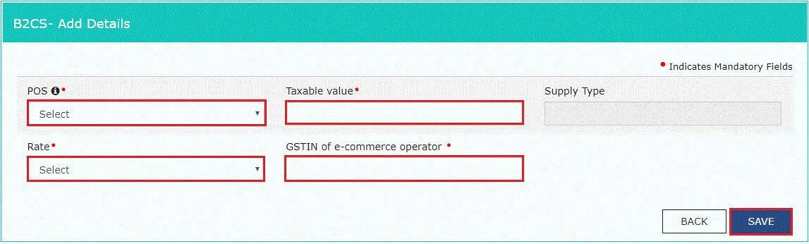

Step 4 -Click on back button to go back to GSTR-1 page. You can see the summary of B2C others invoices here.

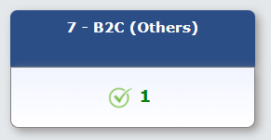

##### 8A, 8B, 8C, 8D – Nil Rated Supplies

All supplies made which attract nill rate of GST should be entered in this tile.

Step 1 – Click on the 8A, 8B, 8C, 8D – Nil Rated Supplies tile

Step 2 -Click on edit to make the fields editable.

67

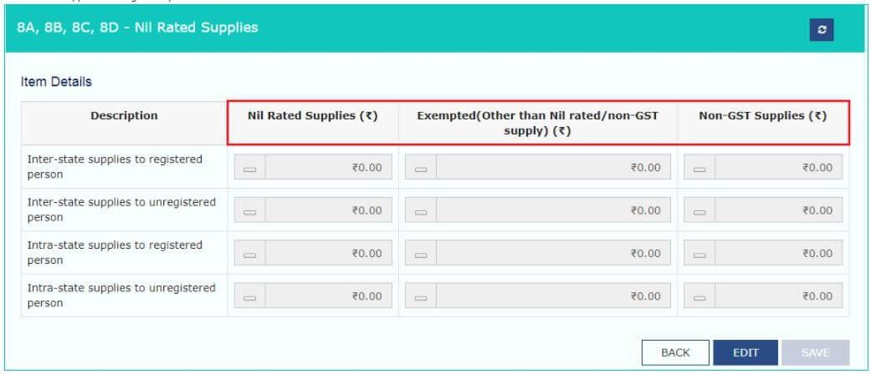

Step 3 – Now enter Nil Rated Supplies, Exempted (Other than Nil rated/non-GST supply), and Non-GST Supplies Amount for the following category –

Inter-state supply to a registered dealer Inter-state supply to an unregistered dealer Intra-stare supply to a registered dealer Intra-stare supply to an unregistered dealer

Step 4 – Click on save and a success message will be displayed on top.

68

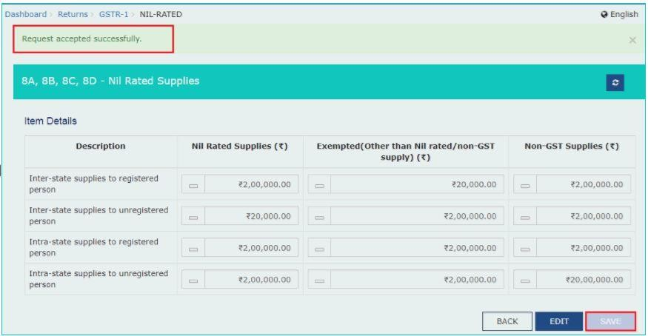

Step 5 -Click on back button to go back to GSTR-1 page. You can see the summary of all nil rated supplies made.

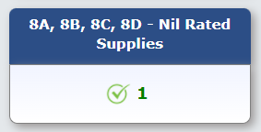

##### 11A(1), 11A(2) – Tax Liability (Advances Received)

All the supplies for which advances were received from the receiver of supplies but invoice was not raised will be entered here.

Step 1 – Click on the 11A(1), 11A(2) – Tax Liability (Advances Received) tile.

Step 2 - The Tax Liability (Advance Received) – Summary page is displayed. Click the ADD STATE WISE DETAILS button to add the advance tax receipt and related liability details.

69

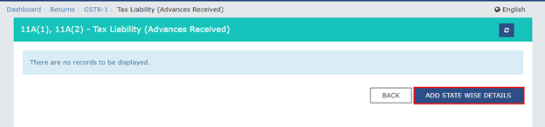

Step 3 – The following details are required to be entered on this page –

Select Place of Supply (State Code) where supply was delivered. The Supply Type field gets auto populated

Enter the Gross Advance Received. IGST or CGST and SGST will be calculated automatically based on supply type(inter-state or intra-state)

Click on Save

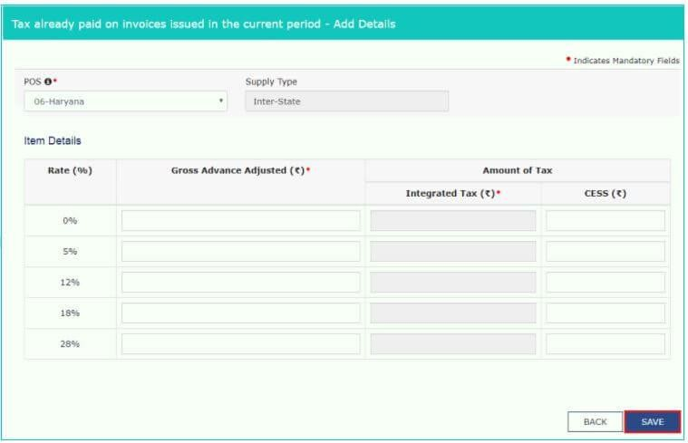

70

Step 4 -Click on back button to go back to GSTR-1 page. You can see the summary of adjustment of advances.

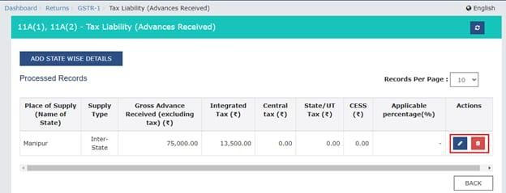

##### 11B(1), 11B(2) – Adjustment of Advances

Details of all the invoices raised in the month for which return is being filed but advance was received and tax was already paid in the previous months has to be entered here

Step 1 – Click on the 11B(1), 11B(2) – Adjustment of Advances tile

Step 2 – Summary page- tax already paid on invoices issued in the current period gets displayed. Click on the ‘ADD STATE WISE DETAILS’ button to add invoice details that were issued in the current period on which tax has already been paid.

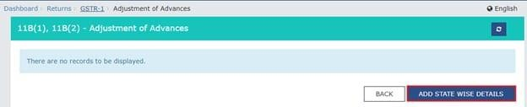

71

Step 3 – The following details have to be entered here –

From the drop-down select the POS i.e. state in which the outward supply is made. The supply type will get pre-filled based on the POS selection

Enter the amount received as an advance in Gross Advance Adjusted field. The IGST or CGST and SGST will be auto calculated

Click on Save button

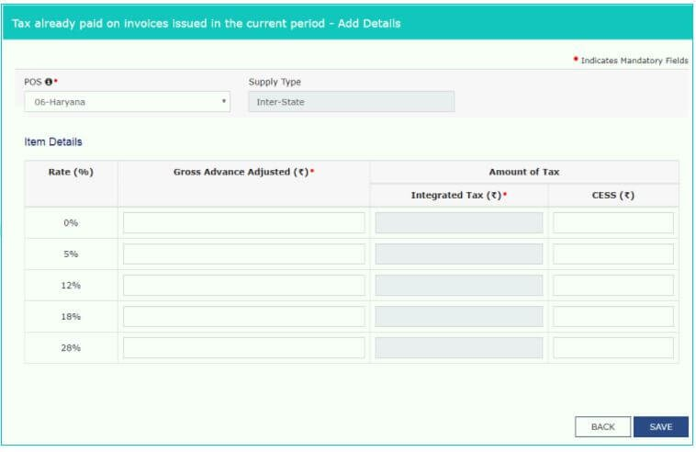

Step 4 – Click on back button to go back to GSTR-1 page. Here you can see the summary of adjustment of advances.

72

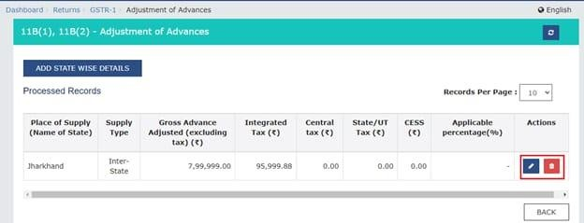

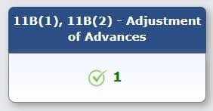

#### HSN

##### 12 – HSN-wise-summary of outward supplies

The GSTR-1 return requires a dealer to provide HSN-wise summary of outward supplies and rate wise along with quantitative details.

Step 1 – Click the HSN-wise summary of outward supplies tile.

Step 2 – Click on Add Details button on bottom right.

73

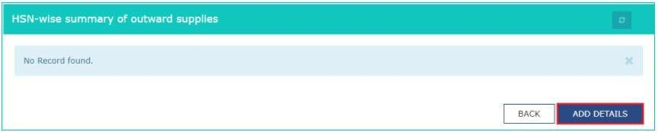

Step 3 – The following are the details to be provided on this page –

HSN Code of outward Supplies Description of the outward supplies

In the ‘UQC’ drop-down select the quantity of the supplies. Eg – KGs, Liters, etc.

Enter the Total Quantity, Total Value and Total Taxable Value of the outward supplies

Now enter the IGST or CGST and SGST based on the type of sale made viz a viz inter-state or intra-state

Click on Add and on the next page click on save button.

74

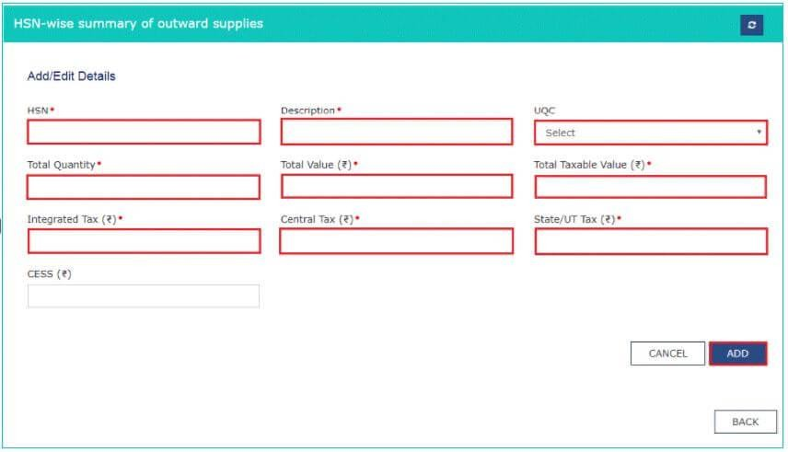

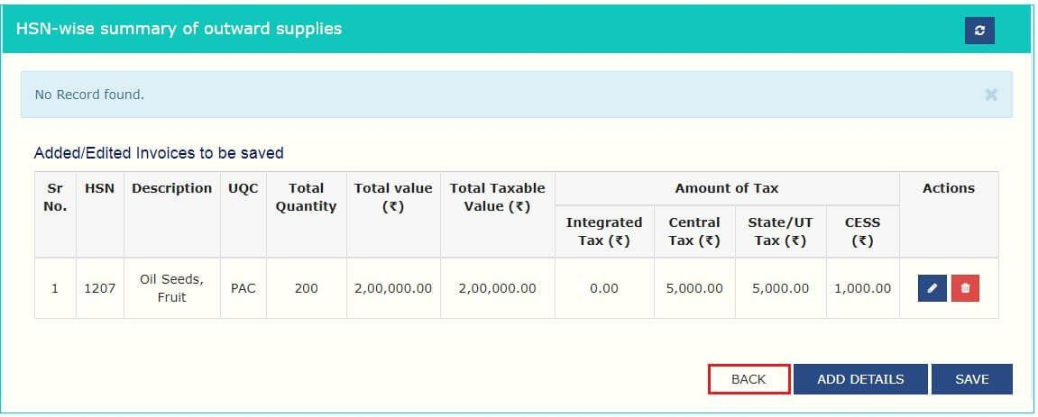

Step 4 – Click on back button to go back to GSTR-1 page. Here you can see the summary of HSN-wise outward supplies.

75

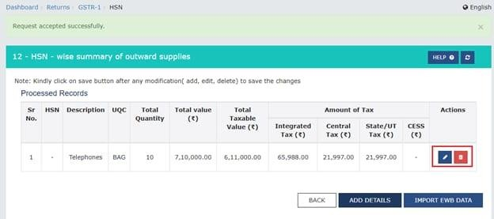

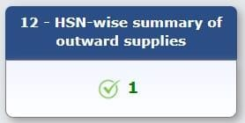

##### 13 – Documents Issued

Every taxpayer is required to provide details of the total document issued during a month.

Step 1 – Click on the tile Documents Issued Step 2 – Click on Add Document

76

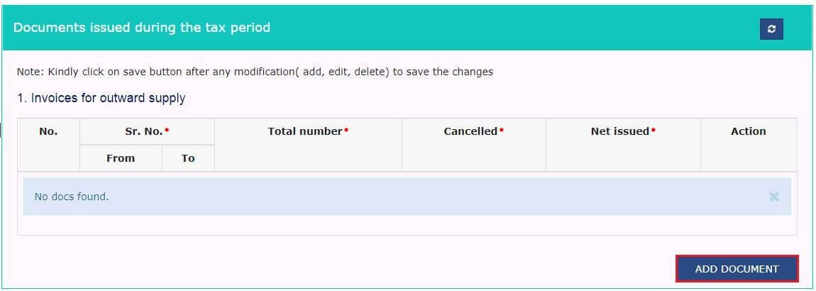

Step 3 – There are will be 12 categories of documents. Enter the serial no. of invoice issued, Total number of invoices issued and cancelled invoices in respective fields. The net invoices field will be auto populated.

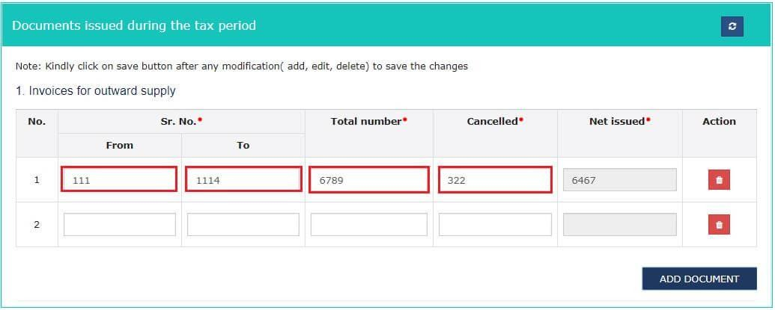

Step 4 – Click on save once all the documents details are entered.

77

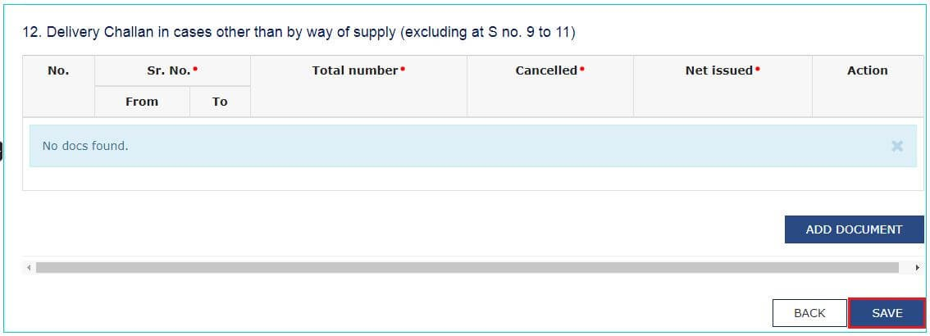

**6. 11A – Amended tax liability (Advance received)** Step 1: Click on the 11A- Amended tax liability tile. Step 2: Select:

Financial year- For which the taxpayer wants to make amendments

Return filing period- For declarations of previous tax periods. Click on the ‘Amend invoice’ button.

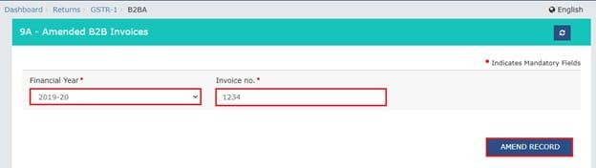

Step 3: Make the amendments as required. But, the place of supply cannot be amended. Click on ‘Save’.

78



Step 4 – Click on save once all the documents details are entered.



**11A – Amended tax liability (Advance received)** Step 1: Click on the 11A- Amended tax liability tile. Step 2: Select:

Financial year- For which the taxpayer wants to make amendments

Return filing period- For declarations of previous tax periods. Click on the ‘Amend invoice’ button.

79



Step 3: Make the amendments as required. But, the place of supply cannot be amended. Click on ‘Save’.

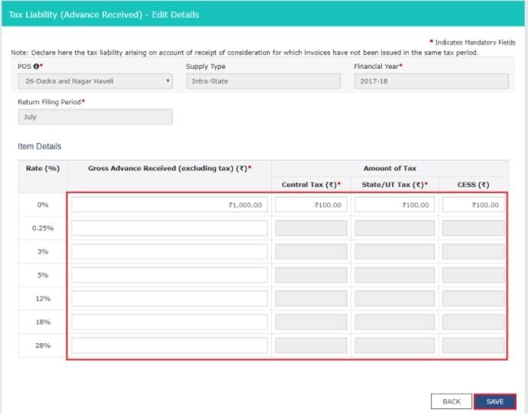

The taxpayer will be directed to the previous page with the message displayed below.

80

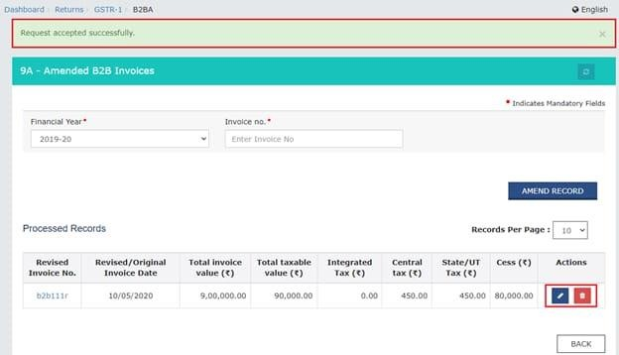

On the GSTR-1 landing page, the ‘11A- Amended tax liability (Advance received)’ tile will be updated with the number of invoices amended along with the taxable value. The taxpayer will have to pay tax in this tax period only on the differential tax liability.

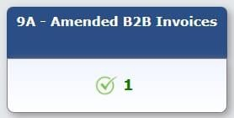

##### 11B Amended of Adjustment of Advances

Step 1: Click on the ‘11B – Amended of adjustment of advances’ tile.

81

Step 2: Select:

Financial year- For which the taxpayer wants to make amendments

Return filing period- For declarations of previous tax periods. Click on the ‘Amend invoice’ button.

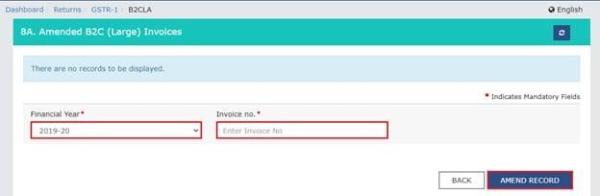

Make the changes as required. Note that you cannot amend the place of supply. Click on the ‘Save’ button.

82

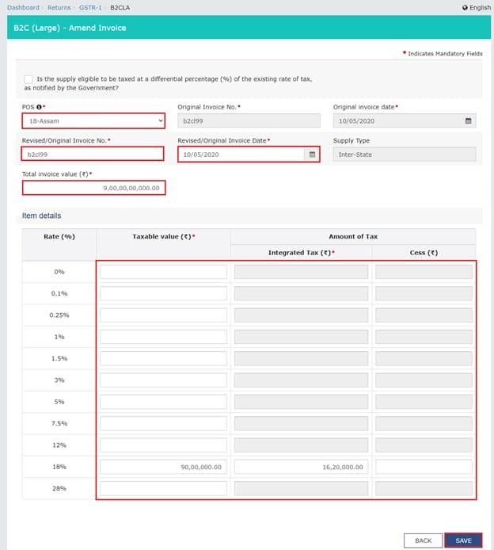

A taxpayer will be redirected to the previous page with a “Request accepted” message

83

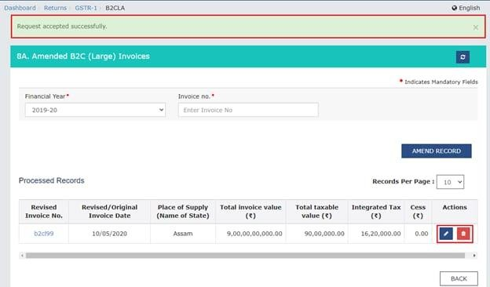

Click on the ‘Back’ button. On the GSTR-1 landing page, the ‘11B- Amended of adjustment of advances’ tile will be updated with the number of invoices amended along with the taxable value. The taxpayer will have to pay tax in this tax period only on the differential tax liability.

Step 1: Click on the ‘10 – Amended B2C (others)’ tile.

Step 2: Select the year and month of the line items of declarations of previous tax periods from the drop-down list. Then select the original POS and click on the ‘Amend details’ button.

84

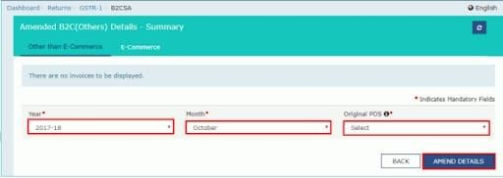

Step 3: Select the revised/original state code from the drop down list. Make the amendments as required. Note that the place of the supply field cannot be amended. Click on ‘Save’.

The taxpayer will be directed to the previous page.

Click on the ‘Back’ button. On the GSTR-1 landing page, the ‘10- Amended B2C (others)’ tile will be updated with the number of invoices amended along with the taxable value. The taxpayer will have to pay tax in this tax period only on the differential tax liability.

# Generate the GSTR-1 summary

Scroll to the bottom of the page and click on the ‘Generate GSTR-1 summary’ to include the auto-populated details pending for action by the recipients.

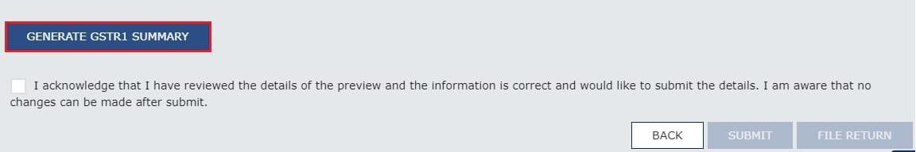

85

The following message will appear on the screen once the summary has been generated. You can check back after one minute.

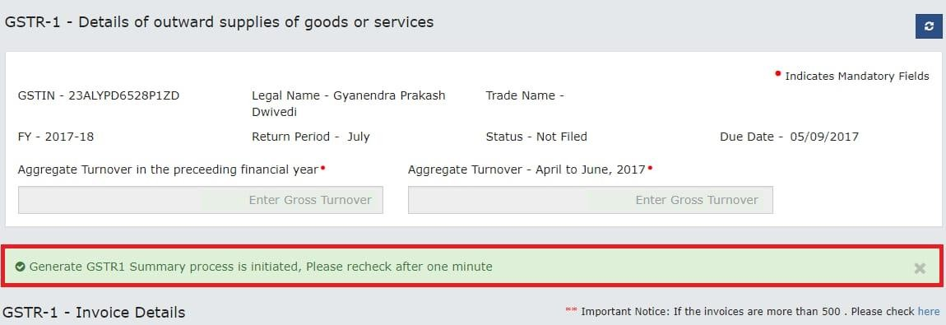

After the summary is generated, a success message will appear on top of the page.

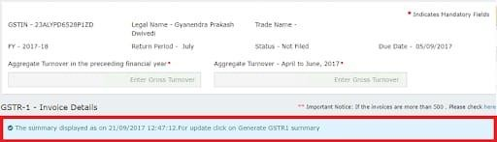

The summary will be generated by the GST Portal automatically at intervals of 30 minutes. To view the summary instantly after adding invoices, you can generate the summary by clicking on the ‘Generate GSTR-1 Summary’ button. However, the summary can be generated only at intervals of 10 minutes. If you

86

attempt to generate the summary before 10 minutes have elapsed, you will notice an error message on the top of the page.

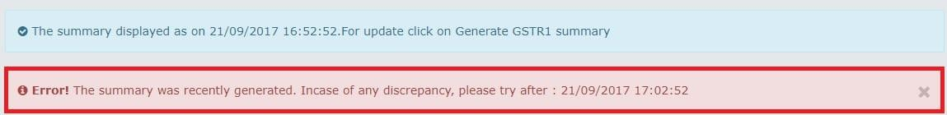

# Preview the GSTR-1

Once the GSTR-1 summary has been generate, click on the ‘Preview’ button. This will download the draft summary of the GSTR-1 return for your review. It is recommended that you review the summary of entries made in the various sections submitting the GSTR-1.

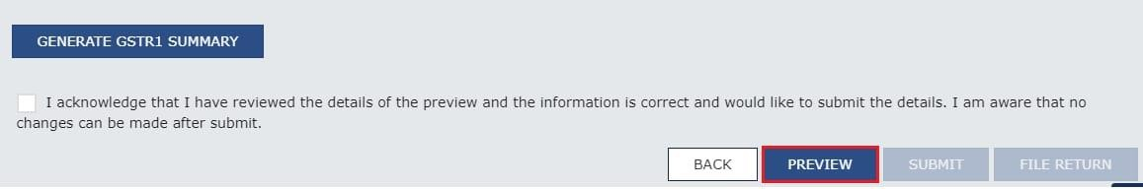

##### Acknowledge and submit the GSTR-1 return

Once the GSTR-1 return is ready to be submitted, select the acknowledgement checkbox confirming that you have reviewed the details and that the information furnished is correct, and that you are aware that no changes can be made after submitting the GSTR-1. Once you select the acknowledgement checkbox, the submit button will be enabled.

87

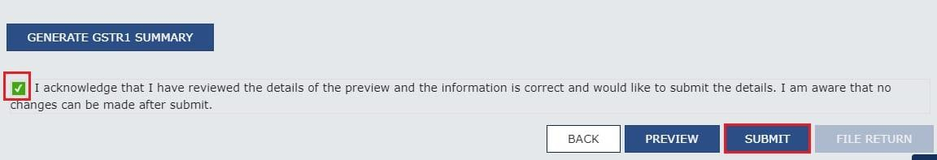

Click on the ‘Submit’ button to submit the GSTR-1. A pop-up will open. Click on ‘Proceed’ if you wish to confirm submission. The GSTR-1 status will change to ‘Submitted’.

##### File GSTR-1 with DSC or EVC

**Once the GSTR-1 return has been submitted, click on the ‘File Return’ button.**

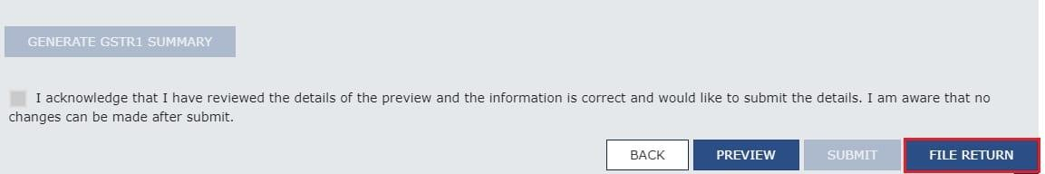

Click on ‘File with DSC’ or ‘File with EVC’, as applicable, to file the GSTR-1 return. Select the digital signature if filing through DSC mode, or enter the OTP sent on the mobile number and email address of the authorized signatory to file via EVC mode.

88

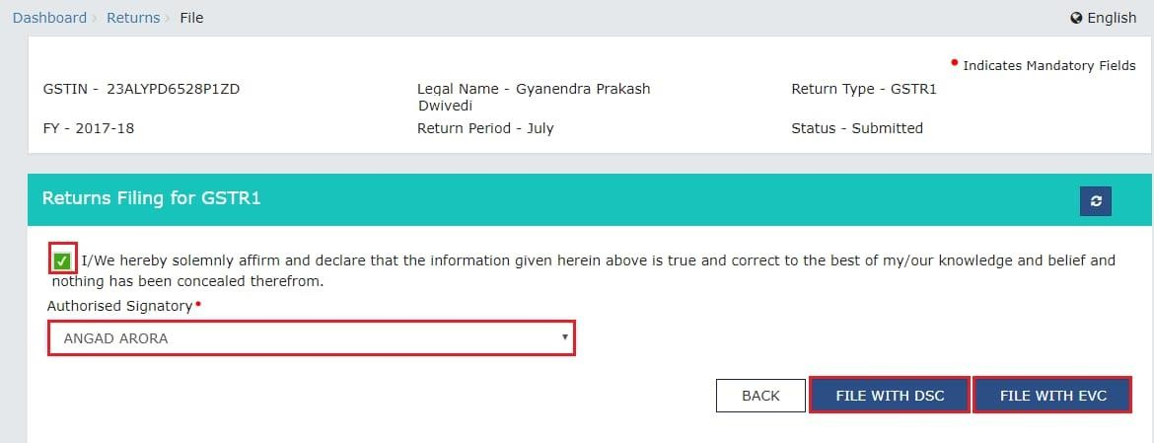

A success message and the ARN will get displayed on successful filing.

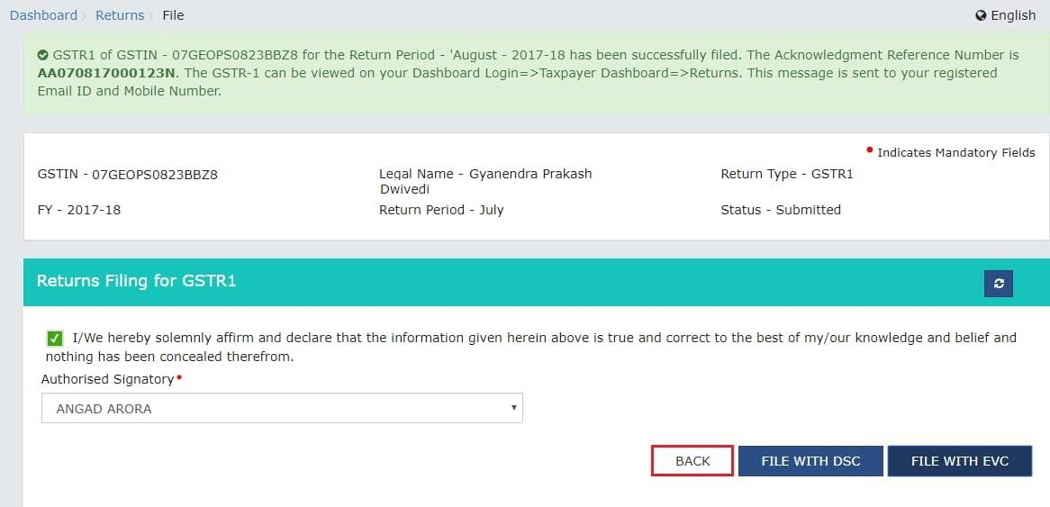

##### GSTR-1.Its simple and easy.

The Goods and Services Tax (GST) portal is an online platform designed to facilitate the administration and management of the GST system in India. Launched by the Government of India, the portal serves as a single point of access for various GST-related activities, making the tax process more streamlined and efficient for businesses and individuals.

89

## A STUDY ON INCOME TAX

During my internship the company, S S auditors and tax consultants.

They just didn’t teach about the tally, they did some theory classes for the interns and question and answer sessions too. They taught us about income tax, TDS and TCS in the theory classes.

#### INCOME TAX:

Income tax as a levy imposed by the government on individuals and businesses based on their earnings or profits. It's a crucial component of government revenue used to fund public services and infrastructure. You can further elaborate on how income tax is calculated, its importance in economic management, and its implications for individuals and businesses. Additionally, you might discuss how different countries handle income tax and any recent developments or reforms in the field.

#### HEADS OF INCOME:

Section 14 of the income tax act classified all incomes under the following.

##### Income from salaries:

"Income from salary" refers to the money an individual earns through employment, typically in the form of wages, salaries, bonuses, commissions, and allowances provided by

90

an employer. It is one of the primary sources of income for many individuals and is often subject to tax deductions at the source (TDS) by the employer before the salary is paid to the employee.

##### Income from house property:

"Income from house property" refers to the money earned from owning a property, whether it's from renting it out to tenants or from other uses such as leasing. This income is one of the heads of income that taxpayers report when filing their tax returns. It encompasses the rental income received from letting out properties, minus any deductions allowed under tax laws, such as property taxes paid and standard deductions.

##### Income from profit and gains from business or profession:

"Income from profit gains from business or profession" refers to the money earned from operating a business or engaging in a profession. It includes the net profit generated from business activities after deducting expenses such as rent, salaries, utilities, and other costs incurred in running the business or practicing the profession. This income is reported by individuals, partnerships, or companies engaged in business or professional activities when filing their tax returns.

##### Income from capital gains:

91

Income from capital gains" refers to the profit earned from the sale of capital assets such as stocks, bonds, real estate, or other investments. When a capital asset is sold for a higher price than its purchase price, the difference is considered a capital gain. Capital gains can be either short- term (if the asset is held for less than a certain period, typically one year) or long-term (if held for more than the specified period).

##### Income from other sources:

Income from other sources" refers to any income that does not fit into the specific categories of salary, house property, business or profession, or capital gains. It includes various types of income such as interest income from savings accounts, fixed deposits, or loans, dividend income from investments, winnings from lotteries or gambling, royalties, and any other miscellaneous income not covered by the other heads of income.

## TDS (TAX DEDUCTED AT SOURCE)

TDS or tax deducted at source, is a method used in India to collect the income tax at the point of income generation. Under this system ascertain percentage of tax is deducted directly by the payer (such as an employer, bank, or tenant) when making specific types of payments (like salary, interest, or rent) to the payee. This deducted tax is then deposited with the government on behalf of the payee. This ensures that tax is collected in a

92

timely manner and reduces the burden of tax payments on individuals at the end of the financial year.

##### Objectives of tax deducted at source:

* Ensure collection of tax at source of income.
* Prevent tax evasion by deducting tax at the time of receipt of income.
* Facilitate a steady revenue stream for the government.
* Help in the detection and prevention of tax avoidance schemes by tracking income streams.

##### Benefits of TDS:

Tax-payers can avoid penalties for non-payment or delayed payments of taxes by ensuring timely TDS compliance.

* TDS makes easier for taxpayers to pay taxes as the tax amount is deducted at the source of the amount.
* Taxpayers can claim TDS as a credit against their tax liability, thus reducing their overall tax burden.
* TDS promotes tax compliance among taxpayers as they are required to deduct and remit taxes to the government on time.

For example, you earn a monthly salary of ₹50,000. As per Indian tax regulations the employer is required to deduct TDS from your tax salary based on your income and applicable tax rates.

TDS applicable for the salary is 10% (50,000*10% ).

93

The employer will deduct ₹5000 from salary and remit it to the government as TDS and the remaining ₹45,000 will be received as net salary.

## TCS (TAX COLLECTED AT SOURCE)

TCS stands for Tax Collected at Source. It's a tax collection mechanism where the seller collects a certain percentage of tax from the buyer at the time of sale of specified goods or services. The seller then deposits this tax collected to the government on behalf of the buyer. TCS is applicable on transactions like sale of goods, lease, of sale of scrap, among others, as per Indian tax regulations.

In simple words it means when you buy certain goods or services, the seller collects a bit of tax from you on behalf of the government and then submits it to the government. Its like a tax collected during the transaction itself.

##### Objectives of tax collected at source;

* Facilitate tax compliance by collecting tax upfront at the time of transaction.
* Reduce the burden on taxpayers by collecting tax at the time of transaction.
* Cover various sectors and industries to ensure comprehensive tax collection.
* Provide a steady revenue stream for the government.

94

For example, suppose you are dealing with sale of goods worth

₹100,000 and the TCS rate applicable for this transaction is 0.1%.

₹100,000*0.1%. The tax collected at source will be ₹100.

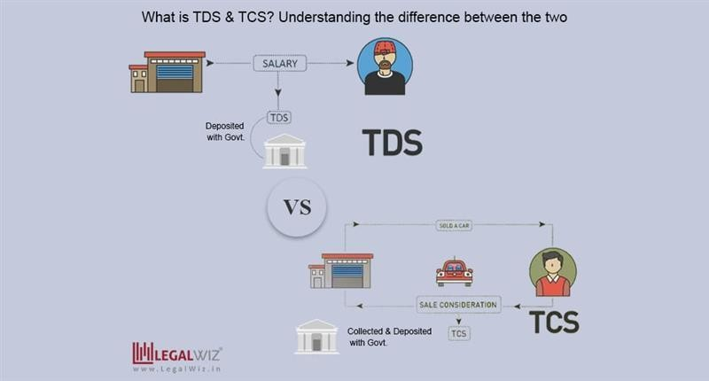

#### BANK STATEMENT TRANSACTION VERIFICATION

Bank statement transaction verification is the process of ensuring that all transactions listed on a bank statement are accurate and legitimate. This process is essential for maintaining financial accuracy, detecting fraudulent activities, and managing personal or business finances effectively.

95

During my internship .MR Irfan sir assigned me task of bank statements verification

Firstly, they gave a bank statement and got access through online banking or just a mailed copy.

Then I gathered all the documents that corresponded to the transaction listed on the bank statement

Then verified the dates of each transaction on the bank statement then matched the dates on the receipt.

After matching the date ensure that the amount listed on the bank statement match the amounts of the receipts but mainly focus on large transactions or which is unusual

Verify the payees and payers. Identifying the unrecognized transactions

Check for the duplicate’s transactions and errors such as incorrect amounts or payee names.

Verify that all fees and charges (e.g., service fees, ATM fees) are correct and as expected. If you find any discrepancies, contact your bank for clarification.

Update your financial records, such as your checkbook or accounting software, to reflect the verified transactions. Ensure that your records and the bank statement are in agreement.

In case if you find any discrepancies or unauthorized transactions, report them to the bank immediately. Most bank

96

have specific procedures for handling disputes and fraud investigations.

## BANK STATEMENT TRANSACTION VERIFICATION IN MS-EXCEL

After verifying the bank statement MR Irfan sir assigned me the same work again but, in this work, I have to verify it through the MS excel software. They handed me a bank statement of a company and informed me to verify in MS excel. They just needed the yearly transaction to be find out, the bank statement was of 3 financial years.

Steps in verification in bank statement; STEP1- Open the MS excel software.

STEP2- Organize the data.

STEP3- Make 3 columns years, debit, and credit.

STEP4- Add first financial year and debit and credit amount in the spreadsheet.

STEP5- After end of every financial year total the amount on debit and credit.

STEP6- Do the same steps for both the remaining financial year.

STEP7 -Cross verify the amount in bank statement as well as the amount in the MS excel.

97

Bank statement transaction verification is a critical task for ensuring the accuracy and integrity of your financial records. By systematically checking each transaction against your records, you can identify and address any errors or unauthorized activities promptly, maintaining financial control and security.

## RECEIPTS AND PAYMENT ENTRY IN TALLY

#### RECEIPT

A receipt is a document that acknowledges the receiving of goods, services, or payment. It typically includes details such as the date, description of what was received, quantity, price, and sometimes the mode of payment. Receipts serve as evidence of a transaction and are often used for record-keeping, accounting, and proof of purchase or payment.

#### PAYMENTS

In general, "payment" refers to the act of giving money or transferring funds to someone in exchange for goods, services, or as settlement of a debt or obligation. It can be done using cash, checks, credit/debit cards, electronic transfers, or other forms of monetary exchange.

During my internship, MS Manjulla ma’am assigned a work and gave 3 years of bank statements of axis bank. my work was to enter the bank statements transactions to tally. It was the

98

same process as I did in my previous works, but in this work, it was a bit different.

## ENTERING PAYMENTS AND RECEPITS IN TALLY.ERP 9

In the bank statement of axis bank, there was just debit and credit columns, and I was confused which was receipt and which was payment, then I clarified the doubt with MS manjulla ma’am who assigned me to do this work.

Identification of receipt amount and payment amount

* If the amount is credited it was a receipt entry
* If the amount is debited it was a payment entry

##### Creation of company and adding total balance

* + Select the company.
  + Go to accounts info.
  + Click on ledgers.
  + Click on create.
  + Enter name, under, address, country, pan number.
  + Enter date.
  + Enter opening balance.

99

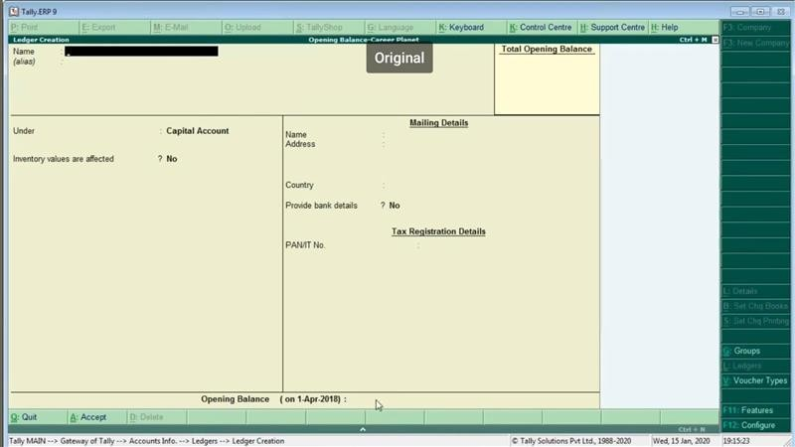

That’s how you create a company and add total balance to the ledger.

After this, as previously mentioned I got the bank statement of axis bank and I have to enter the statement transaction to receipt and payment amount.

The bank statement includes details of the bank, branch, IFSC code , debit and credit amount and in last page there was closing balance of the company

#### STEPS IN ENTERING THE RECEIPT AND PAYMENT;

STEP 1 - Click on accounting vouchers. STEP 2 -Click on

100

* + - F5 for payment
    - F6 for receipt.

STEP 3 - Check the transaction whether the amount is debited or credited, if its credited click on F6

If it’s debited, then click on F5.

STEP 4 - Enter invoice number, date, company name. STEP5 - Enter the ledger account.

If the ledger account is not in the tally create a new ledger by clicking on

ALT+C then enter ledger account name,

If the ledger account is created for the receipts, In the under option select sundry debtors or

If the ledger account is created for the payments, in the under option select sundry creditors.

By these steps the ledger account will be created to both the receipts and payments.

STEP 6 – Enter the amount given in bank statement. STEP 7 - Verify and save the voucher.

After entering all transactions, reconcile them with your bank statement to ensure that the transactions match. Use Tally's reconciliation feature to match your entries with the

101

entries on the bank statement and verify if the closing balance is same as given in the bank statement.

If you did a mistake by not entering the correct ledger account; Click on display and then click on receipts and payments.

Then click on the balance sheet.

Mention the date/month/year correctly or else the closing balance will not be same

By following these steps, you can efficiently enter receipts and payments from a bank statement to the tally.ERP 9 software.

Remember to double check all the entries for the accuracy and to ensure that the bank statement and the receipts and payments records are correct.

102

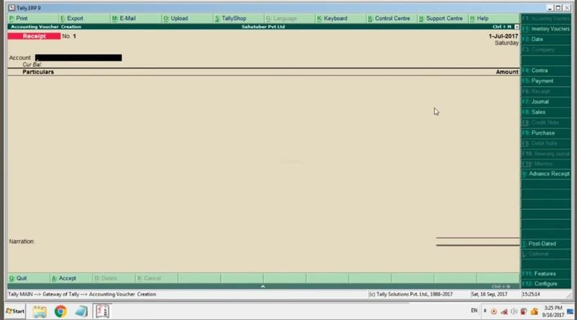

103

## ANNUAL RETURNS OR

**GSTR9**

Annual returns refer to the summary of all the GST transactions done by a registered taxpayer over the financial year. This return contains details such as sales, purchases, tax collected, and input tax credits claimed. It's a way for taxpayers to reconcile their GST liability with the actual transactions they've made throughout the year.

In simple terms, the annual GST returns is like a report card that shows all the buying and selling activities of a business for the entire year, along with the taxes paid and credits claimed.

##### Objectives of annual returns;

1. Transparency: Annual GST returns provide a clear overview of all transactions conducted by a taxpayer throughout the financial year, promoting transparency in business operations.
2. Compliance: Filing annual GST returns is a legal requirement for registered taxpayers under GST regulations, ensuring compliance with tax laws.

104

1. Accuracy: By detailing all sales, purchases, and tax payments, annual GST returns help ensure the accuracy of tax reporting, reducing the likelihood of errors or discrepancies.
2. Tax Reconciliation: Annual GST returns facilitate the reconciliation of input tax credits claimed by the taxpayer with the taxes paid on sales, ensuring that the correct amount of tax is accounted for and minimizing the risk of overpayment or underpayment.
3. Record-Keeping: Filing annual GST returns also serves as a record-keeping mechanism, providing a documented history of a business's GST transactions for auditing purposes or future reference.

During my internship, MS akhila ma’am assigned me task and gave the GST portal login details of 2 different companies with a book and they said to write down annual returns of both the companies in the book.

Format of annual returns, written down in books

* 1. Month
  2. GSTR1
  3. B2C OR CASH
  4. GSTR-2A
  5. GSTR-3B
  6. ITC ELIGIBLE

After writing down the format in the book

105

They taught me how to write the annual returns information in the books.

LOGIN OF GST PORTAL.

STEP1 -go to web browser and search for GST portal. STEP2 -click on the GST portal link.

STEP3 -click on the login.

STEP4 -enter the username and password provided by the company.

STEP5 -enter the captcha.

After logging into GST portal click on annual returns

Then mention the financial year you have to file annual returns, then select the month.

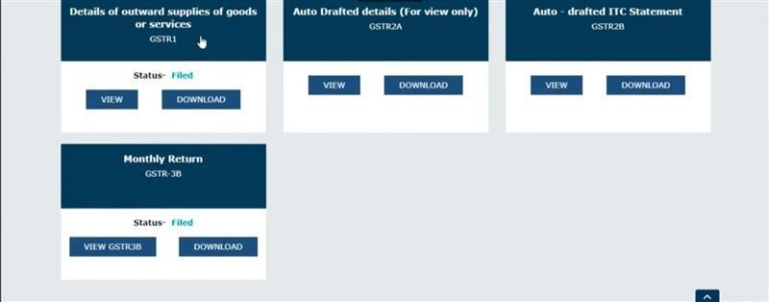

106

This work is a monthly process and should enter every month. STEP 1-

Firstly, we will write down the month and then view the GSTR1.

In GSTR1, you have to click on the view, then scroll down and click on the pdf download option . if pdf is not given click on preview option, there you can find the executive summary of that particular month.

Then we have to enter the total taxable amount, if itsCGST (central goods and services tax) and SGST (state goods and services tax) we have added both the amount and write the amount into the GSTR1 column in the book and check if there is any IGST (Integrated goods and services tax)

Verify if there are any cash sales in the month, if there write the amount in the cash column in the book. The cash option comes in B2C.

STEP 2-

Login to GST portal, click on annual returns and select the month.

Click on GSTR-2A. Click on view.

Click on B2B Invoices

Click on download documents (CSV)

107

After the download the downloaded file will be in opened in MS excel

We have to just add the CGST (central goods and services tax) and SGST (state goods and services tax) and IGST (integrated goods and services tax)

And click to auto sum, then I will be calculated, after getting the total amount we have to enter the amount in the GSTR-2A column.

If there are both inter and intra state transactions write both in the books

STEP 3-

After returning to the dashboard, we have to again select the same month that we have done for both GSTR1 and GSTR-2A. it’s a lengthy process

#### GSTR-3B

GSTR-3B stands for "Goods and Services Tax Return-3B." It is a simplified summary return form used under India's Goods and Services Tax (GST) system. Registered taxpayers use it to report:

* Total outward supplies (sales)
* Inward supplies (purchases) on which input tax credit (ITC) is claimed.
* Tax liability.
* Tax payments.

108

The form must be filed monthly by the 20th of the following month, ensuring the government receives accurate tax data and payments on time.

In GSTR-3B, we can find the total amount of sale and purchase we have done in one financial year with eligible ITC (input tax credit)

After getting the amounts we have to write in the book and the amount of GSTR-3B can be found in the 3.1 tax on outward and reverse charge inward supplies.

There we can find the CGST (central goods and services tax) and SGST (state goods and services tax) and IGST (integrated goods and services tax) amount with health and education cess (if given) after noting down the amount in GSTR-3B column in the book.

Next step is to mention the eligible ITC (input tax credit) and note it in the books, in the eligible ITC column.

Following the same process, I have completed both the annual returns filling if both the given companies.

109

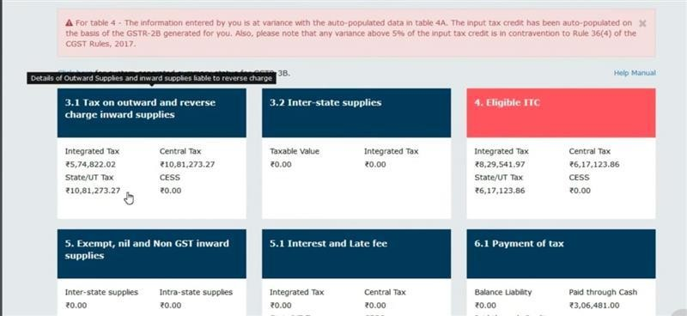

#### FINDINGS AND CONCLUSION FINDINGS;

Tallying sales and purchases using Tally ERP software demonstrated its effectiveness in maintaining accurate records, provided real-time data entry is practiced. Discrepancies typically arose from manual entry errors or delays, highlighting the need for regular audits and checks.

Working with the GST portal revealed that it is user-friendly but requires precise data entry. Filing GST returns highlighted common issues such as data reconciliation errors and invoice mismatches. Handling registrations, although straightforward, often faced delays due to document discrepancies. Responding to GST-related queries, mainly about input tax credit and

110

compliance, underscored the necessity of knowledgeable and timely responses.

Reviewing bank statements regularly helped identify unauthorized transactions and discrepancies. Understanding bank fees and charges was crucial for accurate financial management.

Preparing annual returns required a comprehensive understanding of financial statements and collaboration with different departments for accurate data collection. Timely filing was crucial to avoid penalties. Staying updated on changes in statutory requirements was essential for compliance.

#### CONCLUSION

The task of using the tally. ERP9 software required diligence and attention to detail, showing that regular audits are essential to ensure data accuracy and integrity. The Tally ERP software is a powerful tool for managing financial data, but systematic and meticulous record-keeping is crucial.

The tasks related to the GST portal emphasized the importance of accuracy and staying updated with the latest GST regulations to ensure compliance. Efficient handling of the portal and addressing client queries promptly enhances client satisfaction and reduces the risk of penalties.

The review and reconciliation of bank statements are vital for accurate financial reporting. Prompt and accurate

111

reconciliation ensures the financial health of the company and helps in detecting and rectifying discrepancies timely.

Filing annual returns is a critical task that requires precision and thorough knowledge of financial regulations. Ensuring compliance with statutory requirements avoids penalties and enhances the credibility of the firm. And we should be alert while entering it or writing down in the books.

My internship at SS Auditors and Tax Consultant provided me with valuable insights into the practical aspects of accounting and taxation. I gained hands-on experience in using accounting software, handling financial data, and ensuring compliance with regulatory requirements. The guidance and support from my requirements.

112

## CHAPTER -04 LEARNING OUTCOMES

During my internship, I developed a range of technical skills, particularly in using the accounting software and tools, allowing me to apply theoretical knowledge to practical tasks. This experience significantly enhanced my problem-solving abilities in real world scenarios. This internship journey had helped understanding the tally.ERP 9 software and got the opportunity to work on it.

Throughout this journey I improved my communication skills through regular interactions with my colleagues, communication skill was my weakness which I have overcome in this internship. I also enhanced my teamwork abilities by collaborating with diverse team members and gained knowledge of GST (goods and service tax) and IT (income tax). And gained valuable experience and knowledge on the old and new tax regime.

One of the most significant takeaways of my internship journey was time management skills and problem-solving skills. Managing the time for the day-to-day activities doing the task given for a particular day and if any error occurred in the tally, solving it in a simple way.

Additionally, I learned more about the GST (goods and service tax), IT (income tax) tally.ERP 9 software, tax collected at source (TCS) and tax deducted at source (TDS). And more about the slab rates,

113

Throughout my internship journey I got introduced to the office staff where I was working and they were so warm, caring and were willing to share the knowledge what they have learned in their work they took some internship classes in the office itself and taught about the slab rates, how its calculated. And they did some question-and-answer sessions on what they taught. It was a fun as well as gaining knowledge and overcoming my fear of communication skills.

I felt, like I was a part of their family even though it was for a month,

And I’m grateful for the experience I learned in this internship. Short cuts I learned in tally.ERP 9 software:

The Tally ERP 9 is powerful and user-friendly software for Accounting and Inventory purposes. Also, compared to the cost of other accounting software in the market tally seems to be very reasonable. Similarly, the tally ERP 9 & Prime has inbuilt very core features like shortcut keys. Thus, with the help of the below shortcut keys in tally prime & ERP 9, the user can navigate to any screen within no time. In this article, you will see all such shortcut key lists with their functions. The below keys can be used to reach out to the specified voucher entry screen in the tally. Thus, you need not have to click on the link every time you want to go to the specific voucher entry.

* F1: To select a company.
* F2: To change the date.

114

* F3: To select a voucher type.
* F4: To Contra Voucher
* F5: To Payment Voucher
* F6: To Receipt Voucher
* F7: To Journal Voucher
* F8: To Sales Voucher
* F9: To Purchase Voucher
* F10: To Stock Voucher
* F11: To Company Features
* F12: To Configuration screen

Sometimes the shortcut keys didn’t work, then we have to click on the ALT or FN then we have to use shortcut keys.

If you did the mistake while entering the tally or ledger account or amount

Just click on the Esc button on the keyboard, it will erase all the information in tally and then you can do it once again. The button is a multiple usage in the tally.ERO 9 software.

115

**END OF THE REPORT**

116